**Module Code & Module Title**



**CC6001NA Advanced Database Systems Development**

**Assessment Weightage & Type**

**40% Individual coursework**

**Year and Semester**

**2018-19 Autumn**

**Student Name: Rajat Shrestha**

**London Met ID:** **17030954**

**College ID: np01cp4a170021**

**Assignment Due Date: 30th January 2020**

**Assignment Submission Date: 30th January 2020**

*I confirm that I understand my coursework needs to be submitted online via Google Classroom under the relevant module page before the deadline for my assignment to be accepted and marked. I am fully aware that late submissions will be treated as non-submission and a mark of zero will be awarded.*

Table of Contents

1. Introduction 1

2. Normalization 2

2.1. Figure 1 3

2.1.1. Un-normalized Form (UNF): 4

2.1.2. First Normal Form (1NF): 5

2.1.3. Second Normal Form (2NF): 6

2.1.4. Third Normal Form (3NF): 7

2.2. Figure 2 8

2.2.1. Assumptions For Figure 2: 8

2.2.2. Un-normalized Form (UNF): 10

2.2.3. First Normal Form (1NF): 10

2.2.4. Second Normal Form (2NF): 11

2.2.5. Third Normal Form (3NF): 12

2.3. Integration 13

3. ER-Diagram 14

3.1. Assumptions: 14

3.2. Final ER-diagram: 15

4. Data Dictionary 16

5. Generation of Database 19

5.1. Create Statements 19

5.1.1. Generating DDL Script and Creating Tables: 19

5.2. Insert Statements 24

5.3. Select Statements 30

5.3.1. Day Activities 30

5.3.2. Activity 31

5.3.3. Itinerary 32

5.3.4. Destination 33

5.3.5. Packages 34

5.3.6. Customer Packages 35

5.3.7. Package Guide 36

5.3.8. Customer 37

5.3.9. Staff 38

5.3.10. Role 39

6. Implementation of Web-Based Database Application 40

6.1 Basic Webforms 40

6.1.1. Staff Details 40

6.1.2. Designation Details 41

6.1.3. Customer Details 42

6.1.4. Package Details 43

6.1.5. Tour Guide Details 44

6.2. Complex Webforms 45

6.2.1. Customer-Package Schedule Form 45

6.2.2. Staff-Role Mapping Form 46

6.2.3. Package-Activity Schedule Form 47

6.3. Dashboard 48

7. Testing: 49

7.1. Simple Forms: 49

7.1.1. Adding Data 49

7.1.2. Editing Data 50

7.1.3. Deleting Data 51

7.1.4. Adding Duplicate Data 52

7.1.5. Deleting referenced entry 53

7.2. Complex Forms: 54

7.2.1. Filtering the Package-Customer Form 54

7.2.2. Filtering Staff-Role mapping Form 55

7.2.3. Filtering Package-Activity Schedule Form 56

7.3. Dashboard 57

7.3.1. Testing All of the Links 57

7.3.2. Testing the charts in the Dashboard 58

8. User Manual 59

8.1. CRUD Operations 59

8.1.1. Addition 59

8.1.2. Editing 60

8.1.3. Deleting 61

9. Further Discussion 62

References 63

Appendix 64

**Table of Figures:**

Figure 1: Basic Entities observed via the initial observation 2

Figure 2: Figure 1 as provided by the question 3

Figure 3: Figure 2 as provided by the question for tracking information 8

Figure 4: ER-Diagram created using the given entities 15

Figure 5: Process of generating the DDL Script via SQL developer Datamodeler 19

Figure 6: Running the DDL Script in SQL Developer 23

Figure 7: Running the Insert Statements to populate the database in SQL Developer 29

Figure 8: Running select Statement on Day Activities Table 30

Figure 9: Running select Statement on Activity Table 31

Figure 10: Running select Statement on Itinerary Table 32

Figure 11: Running select Statement on Destination Table 33

Figure 12: Running select Statement on Packages Table 34

Figure 13: Running select Statement on Customer packages Table 35

Figure 14: Running select Statement on Package Guide Table 36

Figure 15: Running select Statement on Customer Table 37

Figure 16: Running select Statement on Staff Table 38

Figure 17: Running select Statement on Role Table 39

Figure 18: Simple Web-forms for Staff Details 40

Figure 19: Simple Web-forms for Designation Details 41

Figure 20: Simple Web-forms for Customer Details 42

Figure 21: Simple Web-forms for Package Details 43

Figure 22: Simple Web-forms for Tour Guide Details 44

Figure 23: Complex Web-forms for Customer-Package Schedule Form 45

Figure 24: Complex Web-forms for Staff-Role Mapping Form 46

Figure 25: Complex Web-forms for Package Activity Schedule Form 47

Figure 26: The Dashboard with Links to webforms and Charts 48

Figure 27: Dashboard with details on the Number of data entered in the database 48

Figure 28: Entering Data in the Customer Form 49

Figure 29: New Customer inserted in the customer table 49

Figure 30: Staff data before editing 50

Figure 31: Editing Staff Data 50

Figure 32: Staff data after editing 50

Figure 33: Designations before deleting 51

Figure 34: Intern designation removed after Deleting 51

Figure 35: Editing the Tour-guide to be duplicate 52

Figure 36: Exception occurred due to duplicate data 52

Figure 37: All the Packages are currently referenced 53

Figure 38: Deleting one referenced data (package) 53

Figure 39: Exception occurred while deleting referenced item 53

Figure 40: Selecting Package Id to show customer booking the selected package 54

Figure 41: Table showing customers who is booking the selected Package 54

Figure 42: Selecting the Designation to count the no of staffs in it and staff details 55

Figure 43: Staff details and count of the selected designation 55

Figure 44: Selecting Package Id to view the enlisted activities 56

Figure 45: Enlisted Activities of the selected package 56

Figure 46: Clicking the staff role link 57

Figure 47: Getting redirected to the staff-role page 57

Figure 48: Charts and data before updating data in the database 58

Figure 49: Charts and data after updating the database 58

**Table of Tables:**

Table 1: Storing Value from the given figure in Atomic cells 3

Table 2: Storing the given data in Atomic cells 9

Table 3: Data Dictionary for the Activity table 16

Table 4: Data Dictionary for Day Activities table 16

Table 5: Data Dictionary for Itinerary Table 16

Table 6: Data Dictionary for Destination Table 16

Table 7: Data Dictionary for Package Table 17

Table 8: Data Dictionary for Staff Table 17

Table 9: Data Dictionary for Customer Table 17

Table 10: Data Dictionary for Customer-Package Table 17

Table 11: Data Dictionary for Package Guide Table 18

Table 12: Data Dictionary for role Table 18

Table 13: Test 1 Simple Form Adding Data 49

Table 14: Test 2 Simple Form Editing Data 50

Table 15: Test 3 Simple Form Removing data 51

Table 16: Test 4 Simple Form Adding duplicate data 52

Table 17: Test 5 Simple Form deleting referenced data 53

Table 18: Test 6 Complex Form Customer-Package Filtering 54

Table 19: Test 7 Complex Form Staff role mapping 55

Table 20: Test 8 Complex Form Package activities 56

Table 21: test 9 Checking Links in dashboard 57

Table 22: Test 10: Checking Graphs in Dashboard 58

# Introduction

This is the first coursework of advanced database systems development year-long module and details in the development of a database system to manage daily operations in a travel company. This project includes the development of a Dashboard to view the overall picture of the data entered in the database, view data in the database, add data in the database and edit the data in the database. At first, this report discusses the overall process of the development of how the entities were managed and normalized into various tables to make the database more effective by reducing data redundancy. The report for database design includes the steps for Normalization, Final Third Normal Form of the database, Integrating the Normalization of two different viewpoints of daily transaction, the addition of New entities, assumptions, and finally, the combined ER-Diagram created according to the provided instruction. Then the tables are created, populated with data and then thoroughly checked. After the insertion of data simple forms are created to manipulate the data, complex forms for viewing data from multiple tables. The forms are created by the help of .Net Framework of C# Programming Language by providing an interface to do various operations on the connected Oracle Database.

The Final Application created is quite useful to view insights on the data inserted to the database and provides basic CRUD functions for essential entities such as Designation, Staffs, Customers, Assigned Tour-Guide, and Packages. Adding Packages is currently only possible via manual insertion by the administrator so it is not included. On top of the basic forms, the complex forms give the option to view various option such as Packages booked by the customer, Staff Count and Details, and Package-Activity details which provide essential operations to the operator. The dashboard provided also includes various tables and charts to give insight on the data stored. The instructions to use all of these forms in the application are described in the user manual and are extensively tested. All of the essential screenshots of the development phase is provided in chronological order.

# Normalization

It is the process of correcting table structure to reduce redundancy and data anomalies, which minimizes storage space. It applies a series of rules called normal forms (Coronel & Morris, 2018). The database in the coursework is required to be normalized till 3NF.

According to the scenario the tour company have the following relation between the entities:

* Staffs have different roles assigned one for each
* Multiple Staffs (specifically tour guides) could be assigned for a tour
* Customer can only take one package from multiple available packages.
* The tour and package are taken as the same entity
* A registered customer might or might not have a tour assigned
* The role is taken as an attribute of staff

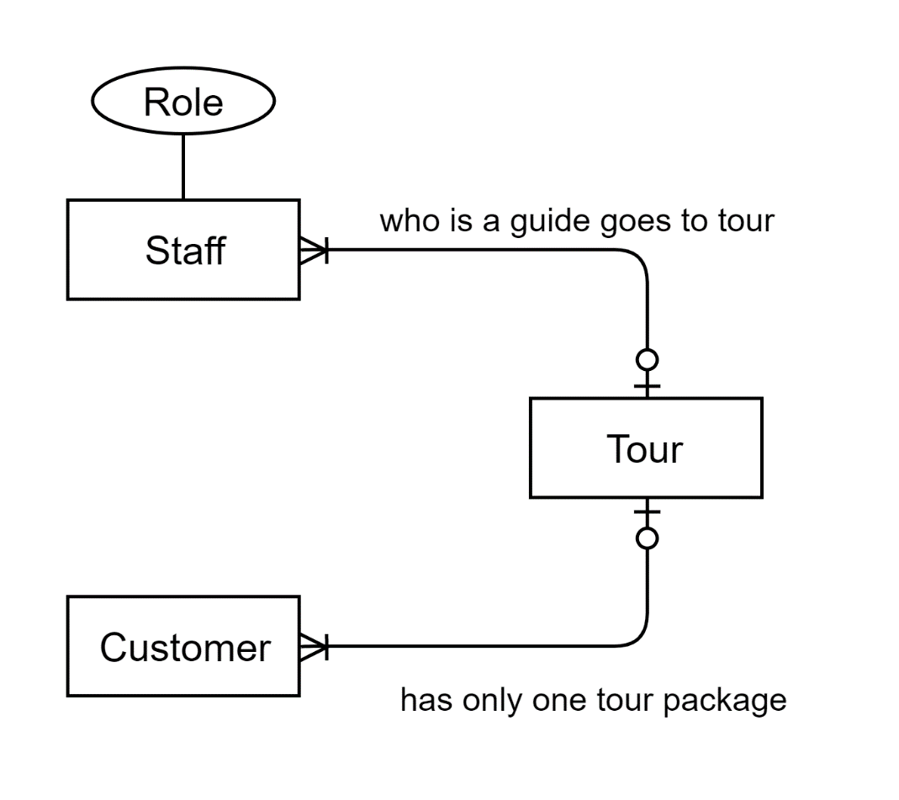

Figure : Basic Entities observed via the initial observation

## Figure 1

The given figure gives us detail about the package record.

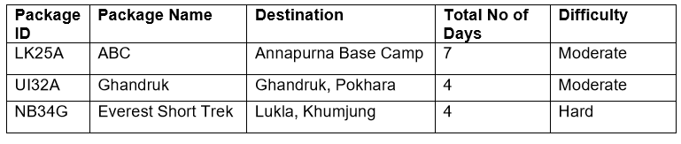

Figure : Figure 1 as provided by the question

As all the information is enough for a package record, storing the given records as atomic value(i.e. storing each value in unique cells) we get:

Table : Storing Value from the given figure in Atomic cells

|  |  |  |  |  |
| --- | --- | --- | --- | --- |
| **Package ID** | **Package Name** | **Destination** | **Days** | **Difficulty** |
| LK25A | ABC | Annapurna Base Camp | 7 | Moderate |
| UI32A | Ghandruk | Ghandruk | 4 | Moderate |
| UI32A | Ghandruk | Pokhara | 4 | Moderate |
| NB34G | Everest Short Trek | Lukla | 4 | Hard |
| NB34G | Everest Short Trek | Khumjung | 4 | Hard |

### Un-normalized Form (UNF):

A database is said to be in UNF when it has not been normalized at all. The rules for creating a un-normalized form are:

* Entity and its attributes should be identified
* A Primary key need to be stated
* The repeating group should be acknowledged.

In relation, a distinctive describing a group of multiple entries for a single key attribute occurrence can be known as a repeating group. Example: Multiple items purchased by a customer in a bill (Coronel & Morris, 2018). From the above table we can observe that the destination column has repeating groups in it, representing the given data in UNF:

UNF: (**Package_ID**, Pakage_Name, {Destination}, Total_Days, Difficulty)

The destination is the repeating group because a package might have multiple destinations, for example, Pokhara and Ghandruk. Package_ID is taken as the primary key as it can uniquely identify all columns.

### First Normal Form (1NF):

In First Normal Form, only atomic values are allowed at each cell and discourage repeating groups. For the database to be in 1NF it must be in UNF. The other rules for 1NF are:

* Primary Keys should be identified.
* Repeating groups from UNF must be separated.
* New table should have Composite Primary key including the Primary key of the original table.

As Package_Name, Total_Days, and Difficulty depend upon the Package_ID, it is assigned as a primary key. Package_Name also gives Destination

Package_ID 🡺 Pakage_Name, Total_Days, Difficulty

Package_ID 🡺 Destination

Removing the repeating group and creating the Destination Package and assigning Package_ID and Destination_ID as composite key and creating the first normal form.

Package (**Package_ID**, Pakage_Name, Total_Days, Difficulty)

Destination_Package (**Package_ID*, Destination**)

### Second Normal Form (2NF):

For the relation to be in Second Normal Form it must already be in First Normal Form and should not include any partial dependencies. Partial dependency is the kind of functional dependencies in which a non-key is dependent on part of a composite key (Coronel & Morris, 2018). The rules for 2NF are:

* All the functional dependencies between no key and composite key and parts of the composite key should be shown for the entities with composite Primary Key.
* Non-keys which are dependent on a part of composite key should be moved to a new table and identify its keys.

In the following situation, there are no Partial dependencies as all the non-key elements are directly dependent on their respective primary key.

Package_ID 🡺 Pakage_Name, Total_Days, Difficulty

Package_ID and Destination gives the unique value for every package-destination pair:

Package (**Package_ID**, Pakage_Name, Total_Days, Difficulty)

Destination_Package (**Package_ID\***, **Destination**)

### Third Normal Form (3NF):

For the database to be in Third Normal Form it must already be in Second Normal Form and should not include any transitive dependencies. Transitive dependency is a type of functional dependency in which a non-key is dependent on another non-key element (Coronel & Morris, 2018). The rules for 3NF are:

* Functional dependencies between no key and non-key should be separated into a new table in case of an entity with multiple Non-key.
* Primary Keys of the new table should be identified.

There are no transitive dependencies as every none key entries are dependent on the primary key assigned for each table.

Package (**Package_ID**, Pakage_Name, Total_Days, Difficulty)

Destination_Package (**Package_ID\***, **Destination**)

Since there are no transitive dependencies this is the final normalized form

## Figure 2

The second figure gives us detail about the tracking information.

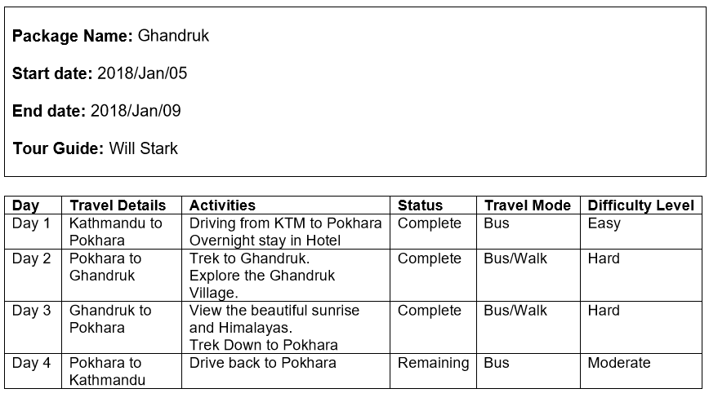

Figure : Figure 2 as provided by the question for tracking information

### Assumptions For Figure 2:

* Activity, Travel Mode and Status depends on the Activity ID assigned for dividing activities
* A day in a package will determine travel details, difficulty and unique sets of activities consisting of activity, travel mode and the status of the day.
* Package ID details the tracking information of the tour.
* Status describes the activity progress

Storing the given records in unique cells we get the following table:

Table : Storing the given data in Atomic cells

|  |  |  |  |  |  |  |  |  |  |  |  |
| --- | --- | --- | --- | --- | --- | --- | --- | --- | --- | --- | --- |
| **Package ID** | **Package Name** | **Start Date** | **End Date** | **Guide** | **Day** | **Travel Details** | **Difficulty** | **Activity ID** | **Activities** | **Travel Mode** | **Status** |
| UI32A | Ghandruk | 1st Jan 2019 | 7th Jan 2019 | Will Stark | Day 1 | Kathmandu to Pokhara | Easy | A1 | Driving from KTM to Pokhara. | Bus | Complete |
| UI32A | Ghandruk | 1st Jan 2019 | 7th Jan 2019 | Will Stark | Day 1 | Kathmandu to Pokhara | Easy | A2 | Overnight stay in the Hotel. | Walk | Complete |
| UI32A | Ghandruk | 1st Jan 2019 | 7th Jan 2019 | Will Stark | Day 2 | Pokhara to Ghandruk | Hard | A3 | Trek to Ghandruk. | Bus | Complete |
| UI32A | Ghandruk | 1st Jan 2019 | 7th Jan 2019 | Will Stark | Day 2 | Pokhara to Ghandruk | Hard | A4 | Explore the Ghandruk Village. | Walk | Complete |
| UI32A | Ghandruk | 1st Jan 2019 | 7th Jan 2019 | Will Stark | Day 3 | Ghandruk to Pokhara | Easy | A5 | View the sunrise and Himalayas. | Walk | Complete |
| UI32A | Ghandruk | 1st Jan 2019 | 7th Jan 2019 | Will Stark | Day 3 | Ghandruk to Pokhara | Easy | A6 | Trek Down to Pokhara | Bus | Complete |
| UI32A | Ghandruk | 1st Jan 2019 | 7th Jan 2019 | Will Stark | Day 4 | Pokhara to Kathmandu | Moderate | A7 | Drive back to Kathmandu | Bus | Remaining |

### Un-normalized Form (UNF):

From the above table we can observe that the destination column has repeating groups in it, representing the given data in UNF:

UNF: (**Package_ID**, Package_Name, Start_Date, End_Date, Tour_Guide, {Day, Travel_Details, Difficulty_Level, {Activity_ID, Activity, Travel_Mode, Status}})

### First Normal Form (1NF):

Package ID is taken as the Primary key as it gives

Package_ID 🡺 Package_Name, Start_Date, End_Date, Tour_Guide,

Package_ID, Day 🡺 Travel_Details, Difficulty_Level

Package_ID, Day, Activity_ID 🡺 Activity, Travel_Mode, Status

Removing the repeating group and creating the Itenary_Tour. Assigning Package_ID as Primary key and creating the first normal form.

Tour (**Package_ID**, Package_Name, Start_Date, End_Date, Tour_Guide)

Itenary_Tour (**Package_ID**\*, **Day**, Travel_Details, Difficulty_Level)

Day_Activities (**Package_ID**\*, **Day\***, **Activity_ID**, Activity, Travel_Mode, Status)

### Second Normal Form (2NF):

Here only Activity and Travel mode are in part dependent because it is not related to the Package ID and Package ID but directly dependent on the Activity ID.

Package_ID 🡺 Package_Name, Start_Date, End_Date, Tour_Guide

Package_ID, Day 🡺 Travel_Details, Difficulty_Level

Package_ID 🡺 **X**

Day 🡺 **X**

Package_ID, Day, Activity_ID 🡺 Status

Activity_ID 🡺 Travel_Mode, Activities

Removing the partial dependency, we get:

Tour (**Package_ID**, Package_Name, Start_Date, End_Date, Tour_Guide)

Itenary_Tour (**Package_ID**\*, **Day**, Travel_Details, Difficulty_Level, Status)

Day_Activities (**Package_ID**\*, **Day\***, **Activity_ID**, Status)

Activities(**Activity_ID**, Activity, Travel_Mode)

### Third Normal Form (3NF):

There are no transitive dependencies as every none key entries are dependent on the primary key assigned for each table.

Tour (**Package_ID**, Package_Name, Start_Date, End_Date, Tour_Guide)

Itenary_Tour (**Package_ID**\*, **Day**, Travel_Details, Difficulty_Level)

Day_Activities (**Package_ID**\*, **Day\***, **Activity_ID\***, Status)

Activities(**Activity_ID**, Activities, Travel_Mode)

Since there are no transitive dependencies this is the final normalized form

## Integration

Combining the tables, we get the following entities. Also adding entities for staffs and customers.

Day_activities (**Package_Id*, Day*, Activity_Id**\*, Status)

Activity (**Activity_Id**, Activity_Name, Travel_Mode)

Itinerary (**Package_Id*, Day**, Difficulty_Level, Travel_Details)

Destination (**Package_Id\***, **Destination**)

Packages (**Package_Id*,** Package_Name, Total_Days, Start_Date, End_Date, Difficulty)

Customer_Package (**Customer_Id*, Package_Id\***)

Package_Guide (**Package_Id*, Staff_Id\***)

Customer (**Customer_Id**, First_Name, Last_Name Address, Phone_No)

Staff (**Staff_Id**, First_Name, Last_Name, Address, Phone_No, Role_Id)

Role (**Role_Id**, Description)

# ER-Diagram

An Entity-relationship diagram represents the relationship between the entities in the database. ERD is one of the most common data but effective models where objects are divided into entities and their characteristics into attributes and entities are connected via elaborate relationships. (Nishadha, 2017). SQL Developer Data Modeler is a free graphical tool that improves productivity and simplifies data modelling tasks where users can create, browse and edit, logical, relational, physical, multi-dimensional, and data type models supporting collaborative development through integrated source code control (Oracle, 2020). SQL Developer Data Modeler was used to Create the final ER-Diagram.

Now, we have all the tables from figure 1 and 2 we can observe that the package table from figure 1 and tour table from figure 2 gives the same information. Now for integration the created tables into one and adding new tables for clarity we need to lay down some assumptions.

## Assumptions:

* Package from the figure(1) and tour from the figure(2) represent the same table.
* Difficulty in package table gives the difficulty in the overall package
* The difficulty in Itinerary gives the difficulty level in each day of the package.
* Staffs have Name (first name and last name), address and phone number.
* Staffs are identified by Staff ID.
* Guides are also staff and have guide ID which is referenced to the staff ID in a tour.
* Each staff have only one role assigned to them by the company
* The guide from the package is removed as a package might have multiple guides.
* While adding guides in the tour guide table, the user must only enter the staff who is a guide. (ie. The database will accept a receptionist as a tour guide but that is not ideal)
* Customers have Name (first name and last name), address and phone number.
* Staffs are identified by Staff ID
* Customers can only book one package only once at a time
* A Package can have no guide assigned; the user must avoid while entering data

## Final ER-diagram:

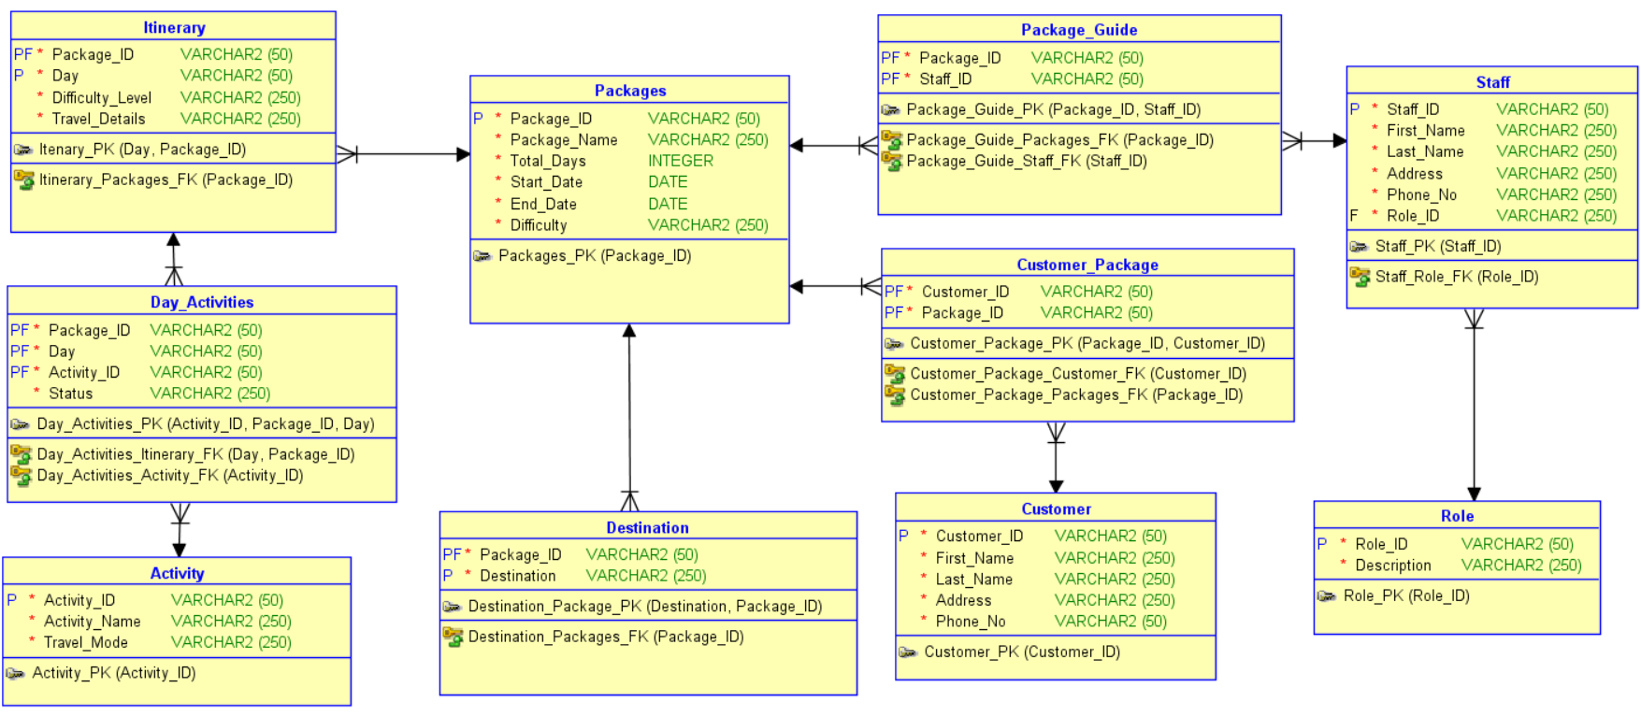

Figure : ER-Diagram created using the given entities

# Data Dictionary

Table : Data Dictionary for the Activity table

|  |  |  |  |  |  |  |  |  |
| --- | --- | --- | --- | --- | --- | --- | --- | --- |
| **Column_Name** | **Mandatory** | **DataType Kind** | **Logical Type Name** | **PK** | **FK** | **Native Type** | **T Size** | **Example** |
| Activity_ID | Y | Logical Type | VARCHAR | P |  | VARCHAR2 | 50 | “A1” |
| Activity_Name | Y | Logical Type | VARCHAR |  |  | VARCHAR2 | 250 | “Doing This” |
| Travel_Mode | Y | Logical Type | VARCHAR |  |  | VARCHAR2 | 250 | “Bus” |

Table : Data Dictionary for Day Activities table

|  |  |  |  |  |  |  |  |  |
| --- | --- | --- | --- | --- | --- | --- | --- | --- |
| **Column_Name** | **Mandatory** | **DataType Kind** | **Logical Type Name** | **PK** | **FK** | **Native Type** | **T Size** | **Example** |
| Activity_ID | Y | Logical Type | VARCHAR | P | F | VARCHAR2 | 50 | “A1” |
| Day | Y | Logical Type | VARCHAR | P | F | VARCHAR2 | 50 | “Day 1” |
| Package_ID | Y | Logical Type | VARCHAR | P | F | VARCHAR2 | 50 | “GAND8” |
| Status | Y | Logical Type | VARCHAR |  |  | VARCHAR2 | 250 | “Incomplete” |

Table : Data Dictionary for Itinerary Table

|  |  |  |  |  |  |  |  |  |
| --- | --- | --- | --- | --- | --- | --- | --- | --- |
| **Column_Name** | **Mandatory** | **DataType Kind** | **Logical Type Name** | **PK** | **FK** | **Native Type** | **T Size** | **Example** |
| Day | Y | Logical Type | VARCHAR | P |  | VARCHAR2 | 50 | “Day 1” |
| Difficulty_Level | Y | Logical Type | VARCHAR |  |  | VARCHAR2 | 250 | “Hard” |
| Package_ID | Y | Logical Type | VARCHAR | P | F | VARCHAR2 | 50 | “GAND8” |
| Travel_Details | Y | Logical Type | VARCHAR |  |  | VARCHAR2 | 250 | “KTM - PKR” |

Table : Data Dictionary for Destination Table

|  |  |  |  |  |  |  |  |  |
| --- | --- | --- | --- | --- | --- | --- | --- | --- |
| **Column_Name** | **Mandatory** | **DataType Kind** | **Logical Type Name** | **PK** | **FK** | **Native Type** | **T Size** | **Example** |
| Destination | Y | Logical Type | VARCHAR | P |  | VARCHAR2 | 250 | “Kathmandu” |
| Package_ID | Y | Logical Type | VARCHAR | P | F | VARCHAR2 | 50 | “GAND8” |

Table : Data Dictionary for Package Table

|  |  |  |  |  |  |  |  |  |
| --- | --- | --- | --- | --- | --- | --- | --- | --- |
| **Column_Name** | **Mandatory** | **DataType Kind** | **Logical Type Name** | **PK** | **FK** | **Native Type** | **T Size** | **Example** |
| Difficulty | Y | Logical Type | VARCHAR |  |  | VARCHAR2 | 250 | “Hard” |
| End_Date | Y | Logical Type | Date |  |  | DATE |  | “1 JAN 2020” |
| Package_ID | Y | Logical Type | VARCHAR | P |  | VARCHAR2 | 50 | “GAND8” |
| Package_Name | Y | Logical Type | VARCHAR |  |  | VARCHAR2 | 250 | “ABC Trek” |
| Start_Date | Y | Logical Type | Date |  |  | DATE |  | “1 JAN 2020” |
| Total_Days | Y | Logical Type | Integer |  |  | INTEGER |  | 4 |

Table : Data Dictionary for Staff Table

|  |  |  |  |  |  |  |  |  |
| --- | --- | --- | --- | --- | --- | --- | --- | --- |
| **Column_Name** | **Mandatory** | **DataType Kind** | **Logical Type Name** | **PK** | **FK** | **Native Type** | **T Size** | **Example** |
| Address | Y | Logical Type | VARCHAR |  |  | VARCHAR2 | 250 | “Jamal” |
| First_Name | Y | Logical Type | VARCHAR |  |  | VARCHAR2 | 250 | “Ram” |
| Last_Name | Y | Logical Type | VARCHAR |  |  | VARCHAR2 | 250 | “Karki” |
| Phone_No | Y | Logical Type | VARCHAR |  |  | VARCHAR2 | 250 | 213122323 |
| Role_ID | Y | Logical Type | VARCHAR |  | F | VARCHAR2 | 250 | “G” |
| Staff_ID | Y | Logical Type | VARCHAR | P |  | VARCHAR2 | 50 | “S110” |

Table : Data Dictionary for Customer Table

|  |  |  |  |  |  |  |  |  |
| --- | --- | --- | --- | --- | --- | --- | --- | --- |
| **Column_Name** | **Mandatory** | **DataType Kind** | **Logical Type Name** | **PK** | **FK** | **Native Type** | **T Size** | **Example** |
| Address | Y | Logical Type | VARCHAR |  |  | VARCHAR2 | 250 | “Jamal” |
| Customer_ID | Y | Logical Type | VARCHAR | P |  | VARCHAR2 | 50 | “C119” |
| First_Name | Y | Logical Type | VARCHAR |  |  | VARCHAR2 | 250 | “Ram” |
| Last_Name | Y | Logical Type | VARCHAR |  |  | VARCHAR2 | 250 | “Karki” |
| Phone_No | Y | Logical Type | VARCHAR |  |  | VARCHAR2 | 50 | 213122323 |

Table : Data Dictionary for Customer-Package Table

|  |  |  |  |  |  |  |  |  |
| --- | --- | --- | --- | --- | --- | --- | --- | --- |
| **Column_Name** | **Mandatory** | **DataType Kind** | **Logical Type Name** | **PK** | **FK** | **Native Type** | **T Size** | **Example** |
| Customer_ID | Y | Logical Type | VARCHAR | P | F | VARCHAR2 | 50 | “C119” |
| Package_ID | Y | Logical Type | VARCHAR | P | F | VARCHAR2 | 50 | “GAND8” |

Table : Data Dictionary for Package Guide Table

|  |  |  |  |  |  |  |  |  |
| --- | --- | --- | --- | --- | --- | --- | --- | --- |
| **Column_Name** | **Mandatory** | **DataType Kind** | **Logical Type Name** | **PK** | **FK** | **Native Type** | **T Size** | **Example** |
| Package_ID | Y | Logical Type | VARCHAR | P | F | VARCHAR2 | 50 | “GAND8” |
| Staff_ID | Y | Logical Type | VARCHAR | P | F | VARCHAR2 | 50 | “S110” |

Table : Data Dictionary for role Table

|  |  |  |  |  |  |  |  |  |
| --- | --- | --- | --- | --- | --- | --- | --- | --- |
| **Column_Name** | **Mandatory** | **DataType Kind** | **Logical Type Name** | **PK** | **FK** | **Native Type** | **T Size** | **Example** |
| Description | Y | Logical Type | VARCHAR |  |  | VARCHAR2 | 250 | “Does This” |
| Role_ID | Y | Logical Type | VARCHAR | P |  | VARCHAR2 | 50 | “DT” |

# Generation of Database

## Create Statements

### Generating DDL Script and Creating Tables:

The Datamodeler allows the generation of DDL Script according to the designed ER-Model. The following figure shows how the script was created and the script is also included. Then the script is pasted into the SQL Developer and ran to generate the tables.

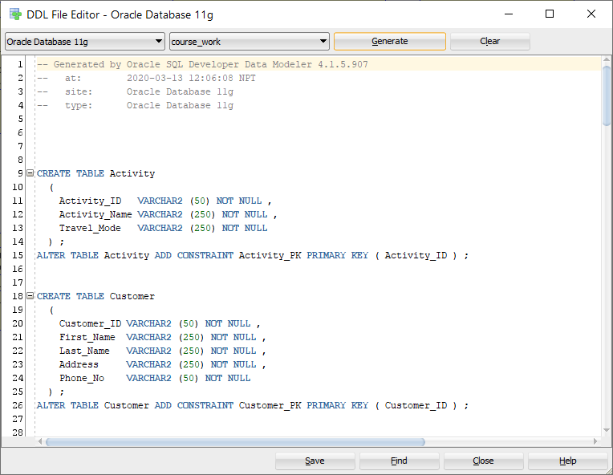

Figure : Process of generating the DDL Script via SQL developer Datamodeler

**DDL Script:**

CREATE TABLE Activity

  (

    Activity_ID   VARCHAR2 (50) NOT NULL ,

    Activity_Name VARCHAR2 (250) NOT NULL ,

    Travel_Mode   VARCHAR2 (250) NOT NULL

  ) ;

ALTER TABLE Activity ADD CONSTRAINT Activity_PK PRIMARY KEY ( Activity_ID ) ;

CREATE TABLE Customer

  (

    Customer_ID VARCHAR2 (50) NOT NULL ,

    First_Name  VARCHAR2 (250) NOT NULL ,

    Last_Name   VARCHAR2 (250) NOT NULL ,

    Address     VARCHAR2 (250) NOT NULL ,

    Phone_No    VARCHAR2 (50) NOT NULL

  ) ;

ALTER TABLE Customer ADD CONSTRAINT Customer_PK PRIMARY KEY ( Customer_ID ) ;

CREATE TABLE Customer_Package

  (

    Customer_ID VARCHAR2 (50) NOT NULL ,

    Package_ID  VARCHAR2 (50) NOT NULL

  ) ;

ALTER TABLE Customer_Package ADD CONSTRAINT Customer_Package_PK PRIMARY KEY ( Package_ID, Customer_ID ) ;

CREATE TABLE Day_Activities

  (

    Package_ID  VARCHAR2 (50) NOT NULL ,

    DAY         VARCHAR2 (50) NOT NULL ,

    Activity_ID VARCHAR2 (50) NOT NULL ,

    Status      VARCHAR2 (250) NOT NULL

  ) ;

ALTER TABLE Day_Activities ADD CONSTRAINT Day_Activities_PK PRIMARY KEY ( Activity_ID, Package_ID, DAY ) ;

CREATE TABLE Destination

  (

    Package_ID  VARCHAR2 (50) NOT NULL ,

    Destination VARCHAR2 (250) NOT NULL

  ) ;

ALTER TABLE Destination ADD CONSTRAINT Destination_Package_PK PRIMARY KEY ( Destination, Package_ID ) ;

CREATE TABLE Itinerary

  (

    Package_ID       VARCHAR2 (50) NOT NULL ,

    DAY              VARCHAR2 (50) NOT NULL ,

    Difficulty_Level VARCHAR2 (250) NOT NULL ,

    Travel_Details   VARCHAR2 (250) NOT NULL

  ) ;

ALTER TABLE Itinerary ADD CONSTRAINT Itenary_PK PRIMARY KEY ( DAY, Package_ID ) ;

CREATE TABLE Package_Guide

  (

    Package_ID VARCHAR2 (50) NOT NULL ,

    Staff_ID   VARCHAR2 (50) NOT NULL

  ) ;

ALTER TABLE Package_Guide ADD CONSTRAINT Package_Guide_PK PRIMARY KEY ( Package_ID, Staff_ID ) ;

CREATE TABLE Packages

  (

    Package_ID   VARCHAR2 (50) NOT NULL ,

    Package_Name VARCHAR2 (250) NOT NULL ,

    Total_Days   INTEGER NOT NULL ,

    Start_Date   DATE NOT NULL ,

    End_Date     DATE NOT NULL ,

    Difficulty   VARCHAR2 (250) NOT NULL

  ) ;

ALTER TABLE Packages ADD CONSTRAINT Packages_PK PRIMARY KEY ( Package_ID ) ;

CREATE TABLE Role

  (

    Role_ID     VARCHAR2 (50) NOT NULL ,

    Description VARCHAR2 (250) NOT NULL

  ) ;

ALTER TABLE Role ADD CONSTRAINT Role_PK PRIMARY KEY ( Role_ID ) ;

CREATE TABLE Staff

  (

    Staff_ID   VARCHAR2 (50) NOT NULL ,

    First_Name VARCHAR2 (250) NOT NULL ,

    Last_Name  VARCHAR2 (250) NOT NULL ,

    Address    VARCHAR2 (250) NOT NULL ,

    Phone_No   VARCHAR2 (250) NOT NULL ,

    Role_ID    VARCHAR2 (250) NOT NULL

  ) ;

ALTER TABLE Staff ADD CONSTRAINT Staff_PK PRIMARY KEY ( Staff_ID ) ;

ALTER TABLE Customer_Package ADD CONSTRAINT Customer_Package_Customer_FK FOREIGN KEY ( Customer_ID ) REFERENCES Customer ( Customer_ID ) ;

ALTER TABLE Customer_Package ADD CONSTRAINT Customer_Package_Packages_FK FOREIGN KEY ( Package_ID ) REFERENCES Packages ( Package_ID ) ;

ALTER TABLE Day_Activities ADD CONSTRAINT Day_Activities_Activity_FK FOREIGN KEY ( Activity_ID ) REFERENCES Activity ( Activity_ID ) ;

ALTER TABLE Day_Activities ADD CONSTRAINT Day_Activities_Itinerary_FK FOREIGN KEY ( DAY, Package_ID ) REFERENCES Itinerary ( DAY, Package_ID ) ;

ALTER TABLE Destination ADD CONSTRAINT Destination_Packages_FK FOREIGN KEY ( Package_ID ) REFERENCES Packages ( Package_ID ) ;

ALTER TABLE Itinerary ADD CONSTRAINT Itinerary_Packages_FK FOREIGN KEY ( Package_ID ) REFERENCES Packages ( Package_ID ) ;

ALTER TABLE Package_Guide ADD CONSTRAINT Package_Guide_Packages_FK FOREIGN KEY ( Package_ID ) REFERENCES Packages ( Package_ID ) ;

ALTER TABLE Package_Guide ADD CONSTRAINT Package_Guide_Staff_FK FOREIGN KEY ( Staff_ID ) REFERENCES Staff ( Staff_ID ) ;

ALTER TABLE Staff ADD CONSTRAINT Staff_Role_FK FOREIGN KEY ( Role_ID ) REFERENCES Role ( Role_ID ) ;

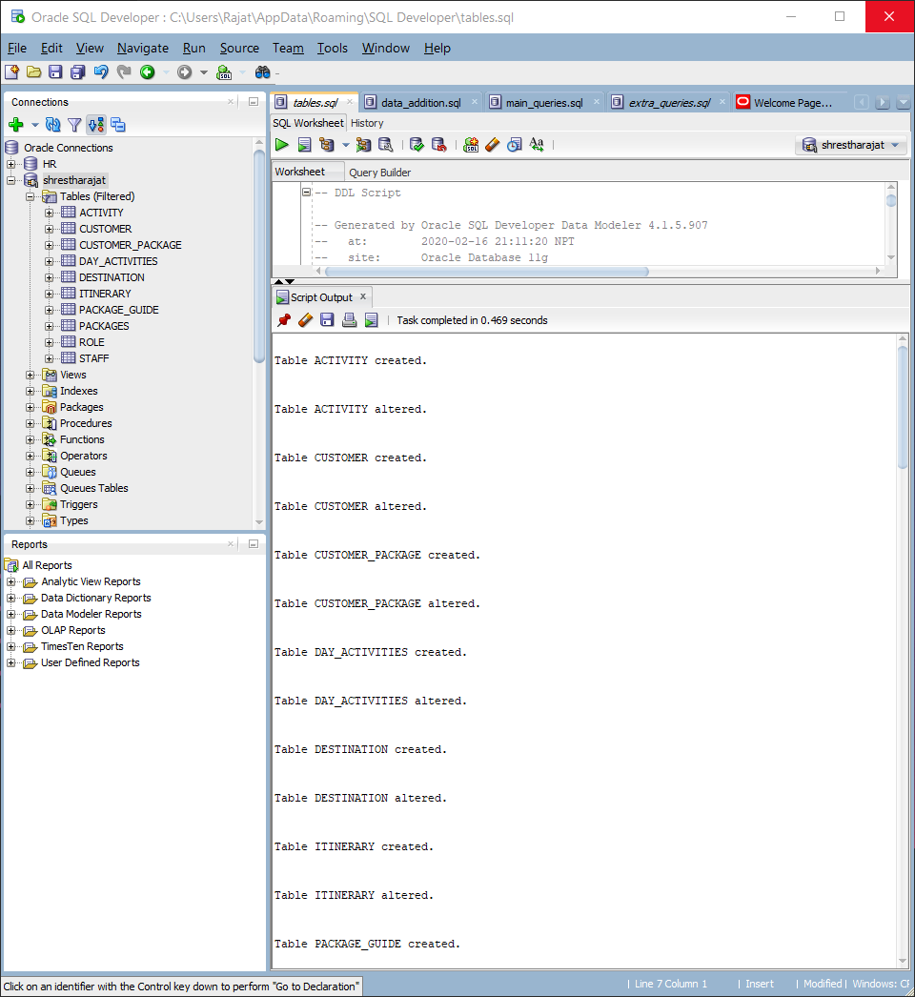

Figure : Running the DDL Script in SQL Developer

## Insert Statements

After creating the tables, they need to be populated. The following data were inserted into the database for testing the database via sql developer

-- Populating the database

INSERT INTO packages (PACKAGE_ID, PACKAGE_NAME, TOTAL_DAYS, START_DATE, END_DATE, DIFFICULTY)

    WITH names AS (

        SELECT 'GAND8', 'Ghandruk', 4, '01-JAN-2020',

'04-JAN-2020', 'Moderate' FROM dual UNION ALL

        SELECT 'ABC21', 'Annapurna BC', 6, '12-FEB-2020',

'17-FEB-2020', 'Hard' FROM dual UNION ALL

        SELECT 'PUNH1', 'Poon-Hill', 5, '01-JAN-2020',

'05-JAN-2020', 'Hard' FROM dual UNION ALL

        SELECT 'EBC77', 'Everest BC', 8, '01-JAN-2020',

'08-JAN-2020', 'Hard' FROM dual UNION ALL

        SELECT 'LUKL1', 'Lukla', 3, '01-MAR-2020',

'03-MAR-2020', 'Moderate' FROM dual

    )

    SELECT * FROM names;

INSERT INTO destination (PACKAGE_ID, DESTINATION)

    WITH names AS (

        SELECT 'GAND8', 'Pokhara' FROM dual UNION ALL

        SELECT 'GAND8', 'Ghandruk' FROM dual UNION ALL

        SELECT 'ABC21', 'Pokhara' FROM dual UNION ALL

        SELECT 'ABC21', 'Ghandruk' FROM dual UNION ALL

        SELECT 'ABC21', 'ABC' FROM dual UNION ALL

        SELECT 'PUNH1', 'Pokhara' FROM dual UNION ALL

        SELECT 'PUNH1', 'Ghorepani' FROM dual UNION ALL

        SELECT 'PUNH1', 'PoonHill' FROM dual UNION ALL

        SELECT 'PUNH1', 'Ghandruk' FROM dual UNION ALL

        SELECT 'LUKL1', 'Lukla' FROM dual UNION ALL

        SELECT 'EBC77', 'Lukla' FROM dual UNION ALL

        SELECT 'EBC77', 'Namche-Bazzar' FROM dual UNION ALL

        SELECT 'EBC77', 'Dingboche' FROM dual UNION ALL

        SELECT 'EBC77', 'EBC' FROM dual

        )

    SELECT * FROM names;

INSERT INTO itinerary (PACKAGE_ID, DAY, TRAVEL_DETAILS, DIFFICULTY_LEVEL)

    WITH names AS (

        SELECT 'GAND8', 'day-1', 'Kathmandu-Pokhara', 'Easy' FROM dual UNION ALL

        SELECT 'GAND8', 'day-2', 'Pokhara-Ghandruk', 'Hard' FROM dual UNION ALL

        SELECT 'GAND8', 'day-3', 'Ghandruk-Pokhara', 'Hard' FROM dual UNION ALL

        SELECT 'GAND8', 'day-4', 'Pokhara-Kathmandu', 'Easy' FROM dual UNION ALL

        SELECT 'ABC21', 'day-1', 'Kathmandu-Pokhara', 'Easy' FROM dual UNION ALL

        SELECT 'ABC21', 'day-2', 'Pokhara-Ghandruk', 'Hard' FROM dual UNION ALL

        SELECT 'ABC21', 'day-3', 'Ghandruk-ABC', 'Hard' FROM dual UNION ALL

        SELECT 'ABC21', 'day-4', 'ABC-Ghandruk', 'Hard' FROM dual UNION ALL

        SELECT 'ABC21', 'day-5', 'Ghandruk-Pokhara', 'Hard' FROM dual UNION ALL

        SELECT 'ABC21', 'day-6', 'Pokhara-Kathmandu', 'Easy' FROM dual UNION ALL

        SELECT 'PUNH1', 'day-1', 'Kathmandu-Pokhara', 'Easy' FROM dual UNION ALL

        SELECT 'PUNH1', 'day-2', 'Pokhara-Ghorepani', 'Hard' FROM dual UNION ALL

        SELECT 'PUNH1', 'day-3', 'Gorepani-Ghandruk', 'Hard' FROM dual UNION ALL

        SELECT 'PUNH1', 'day-4', 'Ghandruk-Pokhara', 'Hard' FROM dual UNION ALL

        SELECT 'PUNH1', 'day-5', 'Pokhara-Kathmandu', 'Easy' FROM dual UNION ALL

        SELECT 'LUKL1', 'day-1', 'Kathmandu-Lukla', 'Easy' FROM dual UNION ALL

        SELECT 'LUKL1', 'day-2', 'Lukla', 'Easy' FROM dual UNION ALL

        SELECT 'LUKL1', 'day-3', 'Lukla-Kathmandu', 'Easy' FROM dual UNION ALL

        SELECT 'EBC77', 'day-1', 'Kathmandu-Lukla', 'Easy' FROM dual UNION ALL

        SELECT 'EBC77', 'day-2', 'Lukla-Namche Bazzar', 'Hard' FROM dual UNION ALL

        SELECT 'EBC77', 'day-3',

'Namche Bazzar-Dingboche', 'Hard' FROM dual UNION ALL

        SELECT 'EBC77', 'day-4', 'Dingboche-EBC', 'Hard' FROM dual UNION ALL

        SELECT 'EBC77', 'day-5', 'EBC-Dingboche', 'Hard' FROM dual UNION ALL

        SELECT 'EBC77', 'day-6',

'Dingboche-Namche Bazzar', 'Hard' FROM dual UNION ALL

        SELECT 'EBC77', 'day-7', 'Namche Bazzar-Lukla', 'Easy' FROM dual UNION ALL

        SELECT 'EBC77', 'day-8', 'Lukla-Kathmandu', 'Easy' FROM dual

    )

    SELECT * FROM names;

INSERT INTO activity (ACTIVITY_ID, ACTIVITY_NAME, TRAVEL_MODE)

    WITH names AS (

        SELECT 'A1', 'Driving from KTM to Pokhara', 'bus' FROM dual UNION ALL

        SELECT 'A2', 'Overnight stay in Hotel', 'stay' FROM dual UNION ALL

        SELECT 'A3', 'Trek to Ghandruk', 'walk' FROM dual UNION ALL

        SELECT 'A4', 'Explore the Ghandruk Village', 'walk' FROM dual UNION ALL

        SELECT 'A5', 'View the sunrise and Himalayas', 'walk' FROM dual UNION ALL

        SELECT 'A6', 'Trek Down to Pokhara', 'walk' FROM dual UNION ALL

        SELECT 'A7', 'Drive back to Kathmandu', 'walk' FROM dual UNION ALL

        SELECT 'A8', 'Trek to ABC from Ghandruk', 'walk' FROM dual UNION ALL

        SELECT 'A9', 'Explore ABC', 'walk' FROM dual UNION ALL

        SELECT 'A10', 'Trek back to Ghandruk from ABC', 'walk' FROM dual UNION ALL

        SELECT 'A11', 'Bus to halfway for ghorepani', 'walk' FROM dual UNION ALL

        SELECT 'A12', 'Trek to Ghorepani', 'walk' FROM dual UNION ALL

        SELECT 'A13', 'Hike to Poonhill', 'walk' FROM dual UNION ALL

        SELECT 'A14', 'Viewing Sunrise', 'walk' FROM dual UNION ALL

        SELECT 'A15', 'Flight to Lukla', 'plane' FROM dual UNION ALL

        SELECT 'A16', 'Explore Lukla', 'walk' FROM dual UNION ALL

        SELECT 'A17', 'Overnight stay in Lukla', 'stay' FROM dual UNION ALL

        SELECT 'A18', 'Flight from Lukla to kathmandu', 'plane' FROM dual UNION ALL

        SELECT 'A19', 'Hike from Lukla to Namche bazzar', 'walk' FROM dual UNION ALL

        SELECT 'A20', 'Trek from Namche to Dingboche', 'walk' FROM dual UNION ALL

        SELECT 'A21', 'Trek from Dingboche to EBC', 'walk' FROM dual UNION ALL

        SELECT 'A22', 'Explore EBC', 'walk' FROM dual UNION ALL

        SELECT 'A23', 'Trek from EBC to Dingboche', 'walk' FROM dual UNION ALL

        SELECT 'A24', 'Trek from Dingboche to Namche', 'walk' FROM dual UNION ALL

        SELECT 'A25', 'Trek from Namche bazzar to Lukla', 'walk' FROM dual

    )

    SELECT * FROM names;

INSERT INTO day_activities (PACKAGE_ID, DAY, ACTIVITY_ID, STATUS)

    WITH names AS (

        SELECT 'GAND8', 'day-1', 'A1', 'Incomplete' FROM dual UNION ALL

        SELECT 'GAND8', 'day-1', 'A2', 'Incomplete' FROM dual UNION ALL

        SELECT 'GAND8', 'day-2', 'A3', 'Incomplete' FROM dual UNION ALL

        SELECT 'GAND8', 'day-2', 'A4', 'Incomplete' FROM dual UNION ALL

        SELECT 'GAND8', 'day-3', 'A5', 'Incomplete' FROM dual UNION ALL

        SELECT 'GAND8', 'day-4', 'A6', 'Incomplete' FROM dual UNION ALL

        SELECT 'ABC21', 'day-1', 'A1', 'Incomplete' FROM dual UNION ALL

        SELECT 'ABC21', 'day-1', 'A2', 'Incomplete' FROM dual UNION ALL

        SELECT 'ABC21', 'day-2', 'A3', 'Incomplete' FROM dual UNION ALL

        SELECT 'ABC21', 'day-2', 'A4', 'Incomplete' FROM dual UNION ALL

        SELECT 'ABC21', 'day-3', 'A8', 'Incomplete' FROM dual UNION ALL

        SELECT 'ABC21', 'day-3', 'A9', 'Incomplete' FROM dual UNION ALL

        SELECT 'ABC21', 'day-4', 'A10', 'Incomplete' FROM dual UNION ALL

        SELECT 'ABC21', 'day-5', 'A5', 'Incomplete' FROM dual UNION ALL

        SELECT 'ABC21', 'day-6', 'A6', 'Incomplete' FROM dual UNION ALL

        SELECT 'PUNH1', 'day-1', 'A1', 'Incomplete' FROM dual UNION ALL

        SELECT 'PUNH1', 'day-1', 'A2', 'Incomplete' FROM dual UNION ALL

        SELECT 'PUNH1', 'day-2', 'A11', 'Incomplete' FROM dual UNION ALL

        SELECT 'PUNH1', 'day-2', 'A12', 'Incomplete' FROM dual UNION ALL

        SELECT 'PUNH1', 'day-3', 'A13', 'Incomplete' FROM dual UNION ALL

        SELECT 'PUNH1', 'day-3', 'A14', 'Incomplete' FROM dual UNION ALL

        SELECT 'PUNH1', 'day-3', 'A3', 'Incomplete' FROM dual UNION ALL

        SELECT 'PUNH1', 'day-4', 'A5', 'Incomplete' FROM dual UNION ALL

        SELECT 'PUNH1', 'day-5', 'A6', 'Incomplete' FROM dual UNION ALL

        SELECT 'LUKL1', 'day-1' , 'A15', 'Incomplete' FROM dual UNION ALL

        SELECT 'LUKL1', 'day-1' , 'A16', 'Incomplete' FROM dual UNION ALL

        SELECT 'LUKL1', 'day-1' , 'A17', 'Incomplete' FROM dual UNION ALL

        SELECT 'LUKL1', 'day-2' , 'A16', 'Incomplete' FROM dual UNION ALL

        SELECT 'LUKL1', 'day-2' , 'A17', 'Incomplete' FROM dual UNION ALL

        SELECT 'LUKL1', 'day-3' , 'A18', 'Incomplete' FROM dual UNION ALL

        SELECT 'EBC77', 'day-1' , 'A15', 'Incomplete' FROM dual UNION ALL

        SELECT 'EBC77', 'day-1' , 'A16', 'Incomplete' FROM dual UNION ALL

        SELECT 'EBC77', 'day-1' , 'A17', 'Incomplete' FROM dual UNION ALL

        SELECT 'EBC77', 'day-2' , 'A19', 'Incomplete' FROM dual UNION ALL

        SELECT 'EBC77', 'day-3' , 'A20', 'Incomplete' FROM dual UNION ALL

        SELECT 'EBC77', 'day-4' , 'A21', 'Incomplete' FROM dual UNION ALL

        SELECT 'EBC77', 'day-4' , 'A22', 'Incomplete' FROM dual UNION ALL

        SELECT 'EBC77', 'day-5' , 'A23', 'Incomplete' FROM dual UNION ALL

        SELECT 'EBC77', 'day-6' , 'A24', 'Incomplete' FROM dual UNION ALL

        SELECT 'EBC77', 'day-7' , 'A25', 'Incomplete' FROM dual UNION ALL

        SELECT 'EBC77', 'day-8' , 'A18', 'Incomplete' FROM dual

    )

    SELECT * FROM names;

INSERT INTO role (ROLE_ID, DESCRIPTION)

    WITH names AS (

        SELECT 'TA', 'Tour Agent, helps customer' FROM dual UNION ALL

        SELECT 'G', 'Guide, goes to tours' FROM dual UNION ALL

        SELECT 'MA', 'Manager, the main manager of the office' FROM dual UNION ALL

        SELECT 'DV', 'Driver, driver for the company' FROM dual UNION ALL

        SELECT 'IN', 'Intern, agent intern in the company' FROM dual

    )

    SELECT * FROM names;

INSERT INTO staff (STAFF_ID, FIRST_NAME, LAST_NAME, ADDRESS, PHONE_NO, ROLE_ID)

    WITH names AS (

        SELECT 'S001', 'Rajat', 'Shrestha', 'Samakhushi, TownPlanning',

'9182934234', 'G' FROM dual UNION ALL

        SELECT 'S002', 'Ashley', 'Green', 'Baluwatar',

'9182343123', 'TA' FROM dual UNION ALL

        SELECT 'S003', 'Shia', 'Miton', 'patan',

'9182323423', 'TA' FROM dual UNION ALL

        SELECT 'S004', 'Ramendra', 'Sharma', 'Gongabu',

'9184322123', 'G' FROM dual UNION ALL

        SELECT 'S005', 'Silas', 'BK', 'Butwal',

'9182931112', 'G' FROM dual UNION ALL

        SELECT 'S006', 'Rabin', 'Tamang', 'Sankhamul',

'91323934234', 'G' FROM dual UNION ALL

        SELECT 'S007', 'Prabin', 'Maskey', 'Baluwatar',

'9182343123', 'G' FROM dual UNION ALL

        SELECT 'S008', 'Pranish', 'Chettri', 'baneshwor',

'9132323423', 'IN' FROM dual UNION ALL

        SELECT 'S009', 'Ramu', 'Sharma', 'Gongabu',

'9184322123', 'G' FROM dual UNION ALL

        SELECT 'S010', 'Ganesh', 'KC', 'Birendranagar',

'9182931112', 'MA' FROM dual

    )

    SELECT * FROM names;

INSERT INTO customer (CUSTOMER_ID, FIRST_NAME, LAST_NAME, ADDRESS, PHONE_NO)

    WITH names AS (

        SELECT 'C001', 'Ramesh', 'Nakarmi', 'Samakhushi, TownPlanning', '9182934234' FROM dual UNION ALL

    SELECT 'C002', 'John', 'LeBron', 'Baluwatar', '9182343423'  FROM dual UNION ALL

    SELECT 'C003', 'Saran', 'Manandar', 'patan', '9182323433'  FROM dual UNION ALL

    SELECT 'C004', 'Susma', 'Shakya', 'Gongabu', '9184422123' FROM dual UNION ALL

    SELECT 'C005', 'Siliya', 'Malla', 'Butwal', '9182931111'  FROM dual UNION AL       SELECT 'C006', 'Shreyash', 'Subedi', 'Sankhamul', '91224234' FROM dual UNION ALL

    SELECT 'C007', 'Bhuwan', 'Khanal', 'Baluwatar', '9382343123' FROM dual UNION ALL

    SELECT 'C008', 'Prashant', 'Budha', 'baneshwor', '933223423' FROM dual UNION ALL

    SELECT 'C009', 'Gopal', 'KC', 'Gongabu', '9184323223' FROM dual UNION ALL

    SELECT 'C010', 'Naren', 'Bajracharya', 'Birendranagar', '9123931112'  FROM dual

    )

    SELECT * FROM names;

INSERT INTO customer_package (CUSTOMER_ID, PACKAGE_ID)

    WITH names AS (

        SELECT 'C001', 'GAND8' FROM dual UNION ALL

        SELECT 'C002', 'EBC77' FROM dual UNION ALL

        SELECT 'C003', 'EBC77' FROM dual UNION ALL

        SELECT 'C004', 'EBC77' FROM dual UNION ALL

        SELECT 'C005', 'PUNH1' FROM dual UNION ALL

        SELECT 'C006', 'ABC21' FROM dual UNION ALL

        SELECT 'C007', 'PUNH1' FROM dual UNION ALL

        SELECT 'C008', 'ABC21' FROM dual UNION ALL

        SELECT 'C009', 'LUKL1' FROM dual UNION ALL

        SELECT 'C010', 'GAND8' FROM dual

    )

    SELECT * FROM names;

INSERT INTO package_guide (PACKAGE_ID, STAFF_ID)

    WITH names AS (

        SELECT 'GAND8', 'S001' FROM dual UNION ALL

        SELECT 'ABC21', 'S004' FROM dual UNION ALL

        SELECT 'ABC21', 'S005' FROM dual UNION ALL

        SELECT 'PUNH1', 'S006' FROM dual UNION ALL

        SELECT 'EBC77', 'S007' FROM dual UNION ALL

        SELECT 'EBC77', 'S009' FROM dual

    )

    SELECT * FROM names;

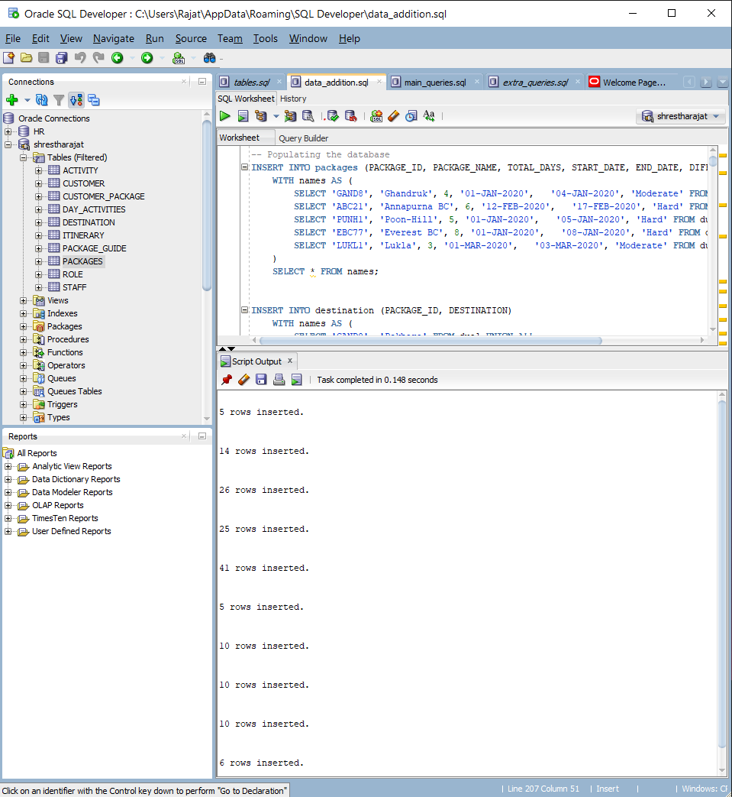

Figure : Running the Insert Statements to populate the database in SQL Developer

## Select Statements

The data inserted are checked using the select statement for each table.

### Day Activities

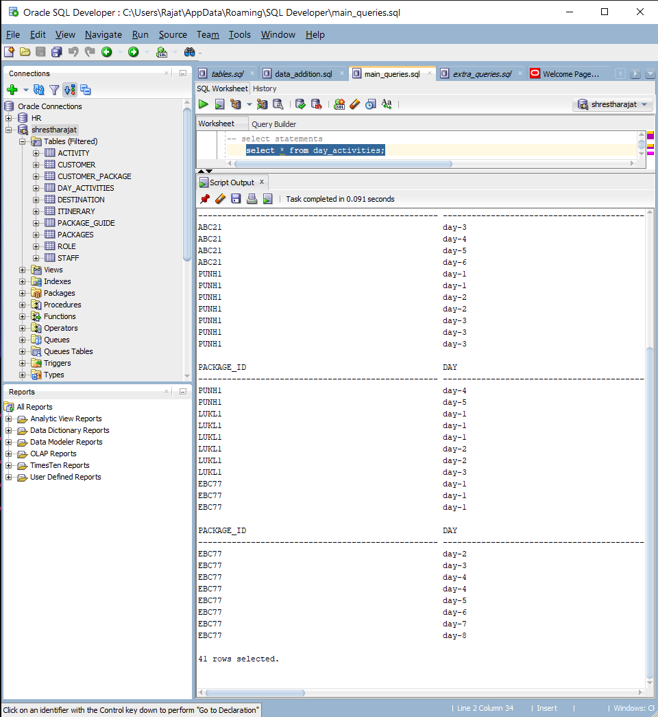

Figure : Running select Statement on Day Activities Table

### Activity

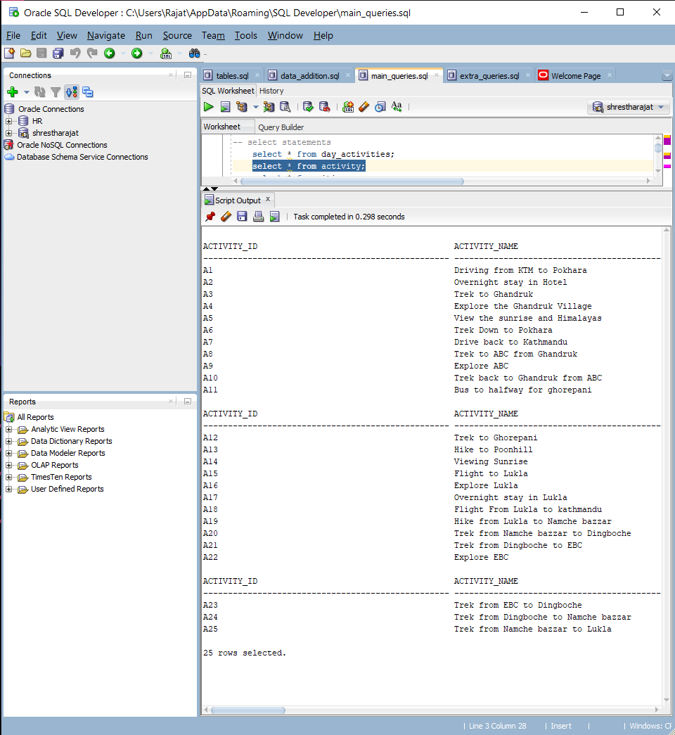

Figure : Running select Statement on Activity Table

### Itinerary

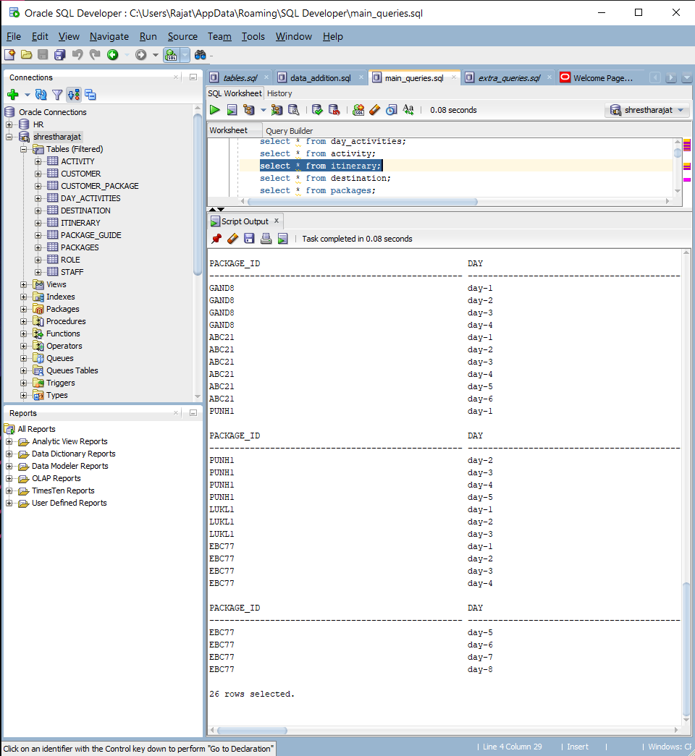

Figure : Running select Statement on Itinerary Table

### Destination

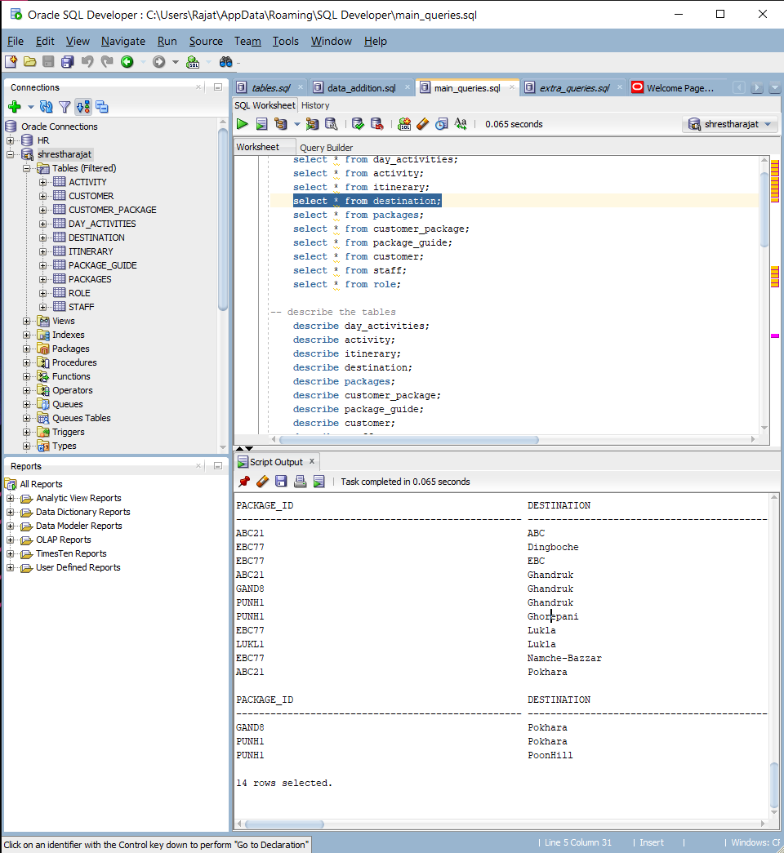

Figure : Running select Statement on Destination Table

### Packages

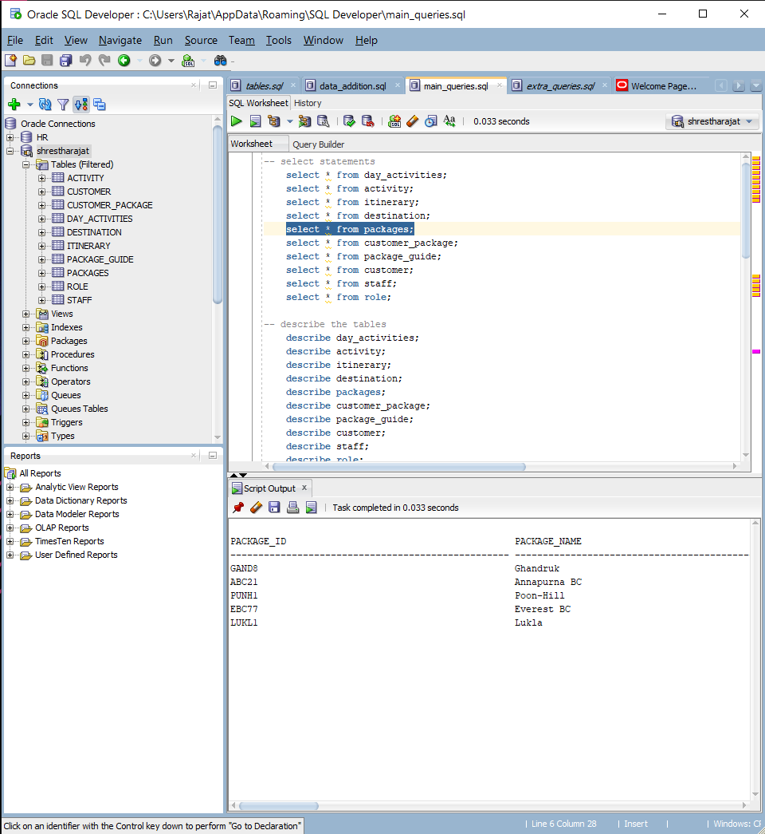

Figure : Running select Statement on Packages Table

### Customer Packages

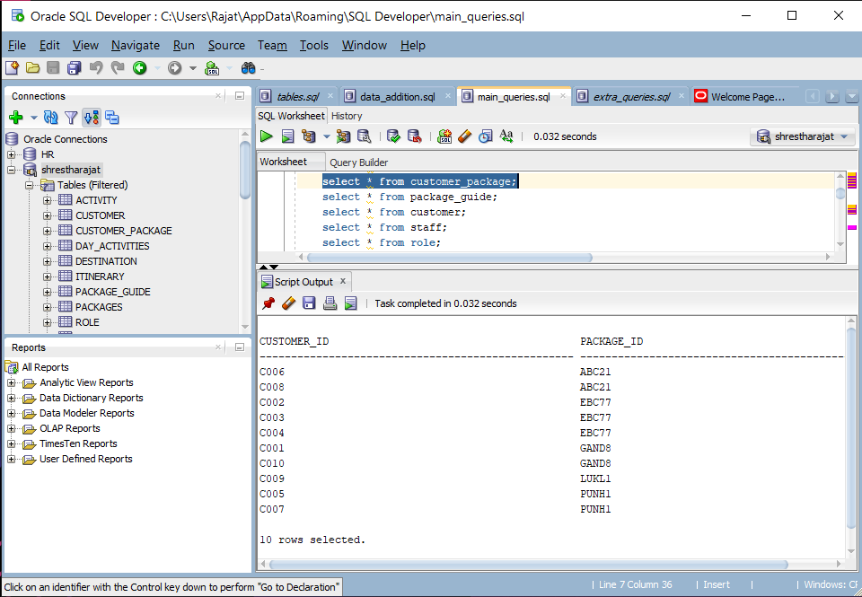

Figure : Running select Statement on Customer packages Table

### Package Guide

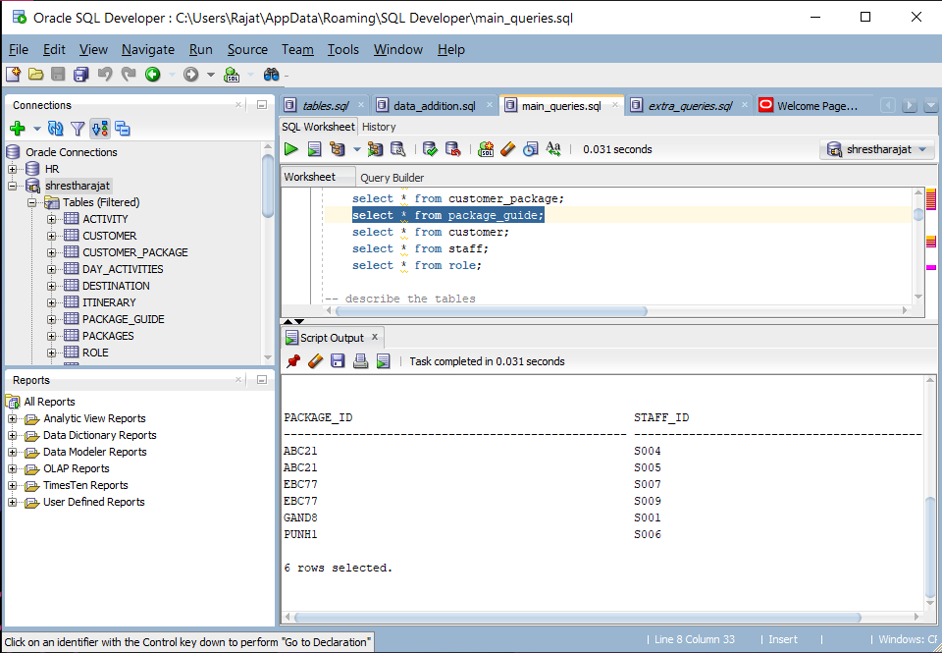

Figure : Running select Statement on Package Guide Table

### Customer

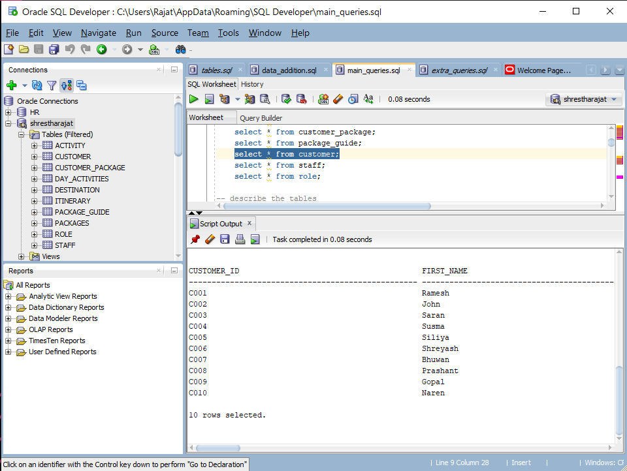

Figure : Running select Statement on Customer Table

### Staff

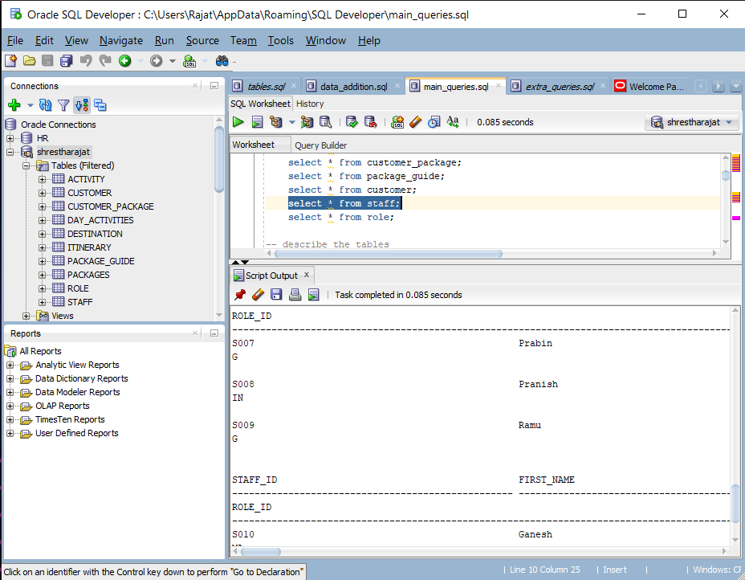

Figure : Running select Statement on Staff Table

### Role

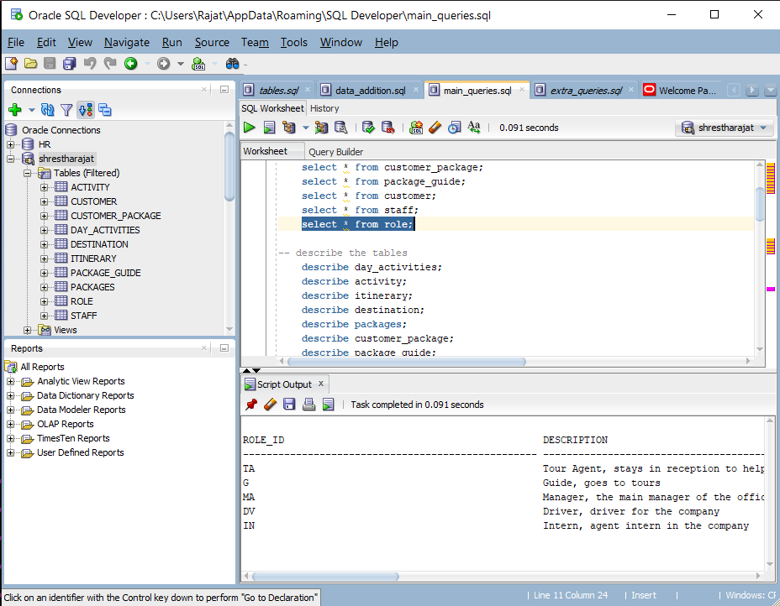

Figure : Running select Statement on Role Table

# Implementation of Web-Based Database Application

## 6.1 Basic Webforms

These forms provide basic functionality for adding, updating or deleting any entries. The Add Delete and Edit Buttons on each Form Provide CRUD functionality for each basic form and the steps for each of the operation is detailed in the user manual.

### Staff Details

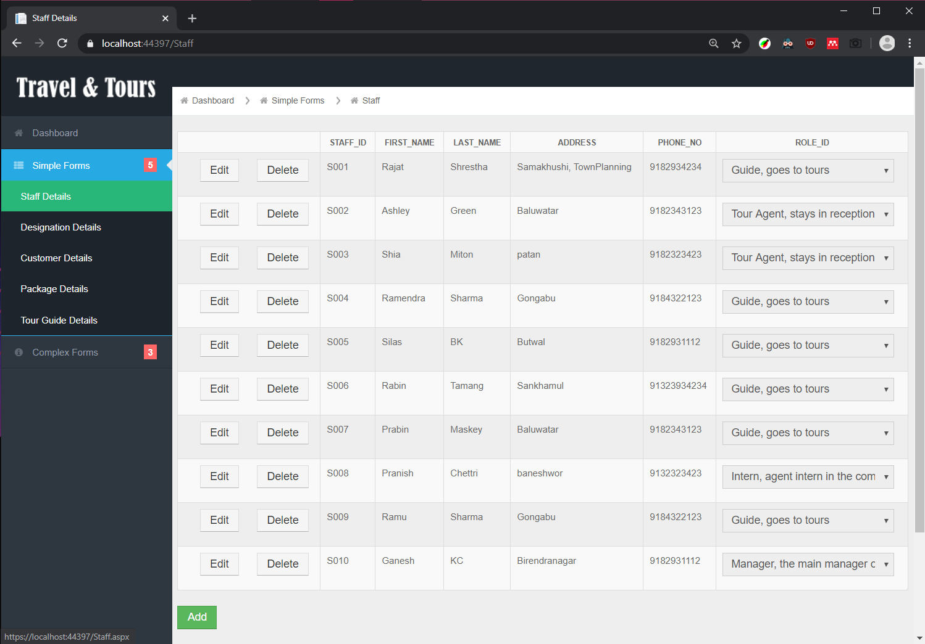

Figure : Simple Web-forms for Staff Details

### Designation Details

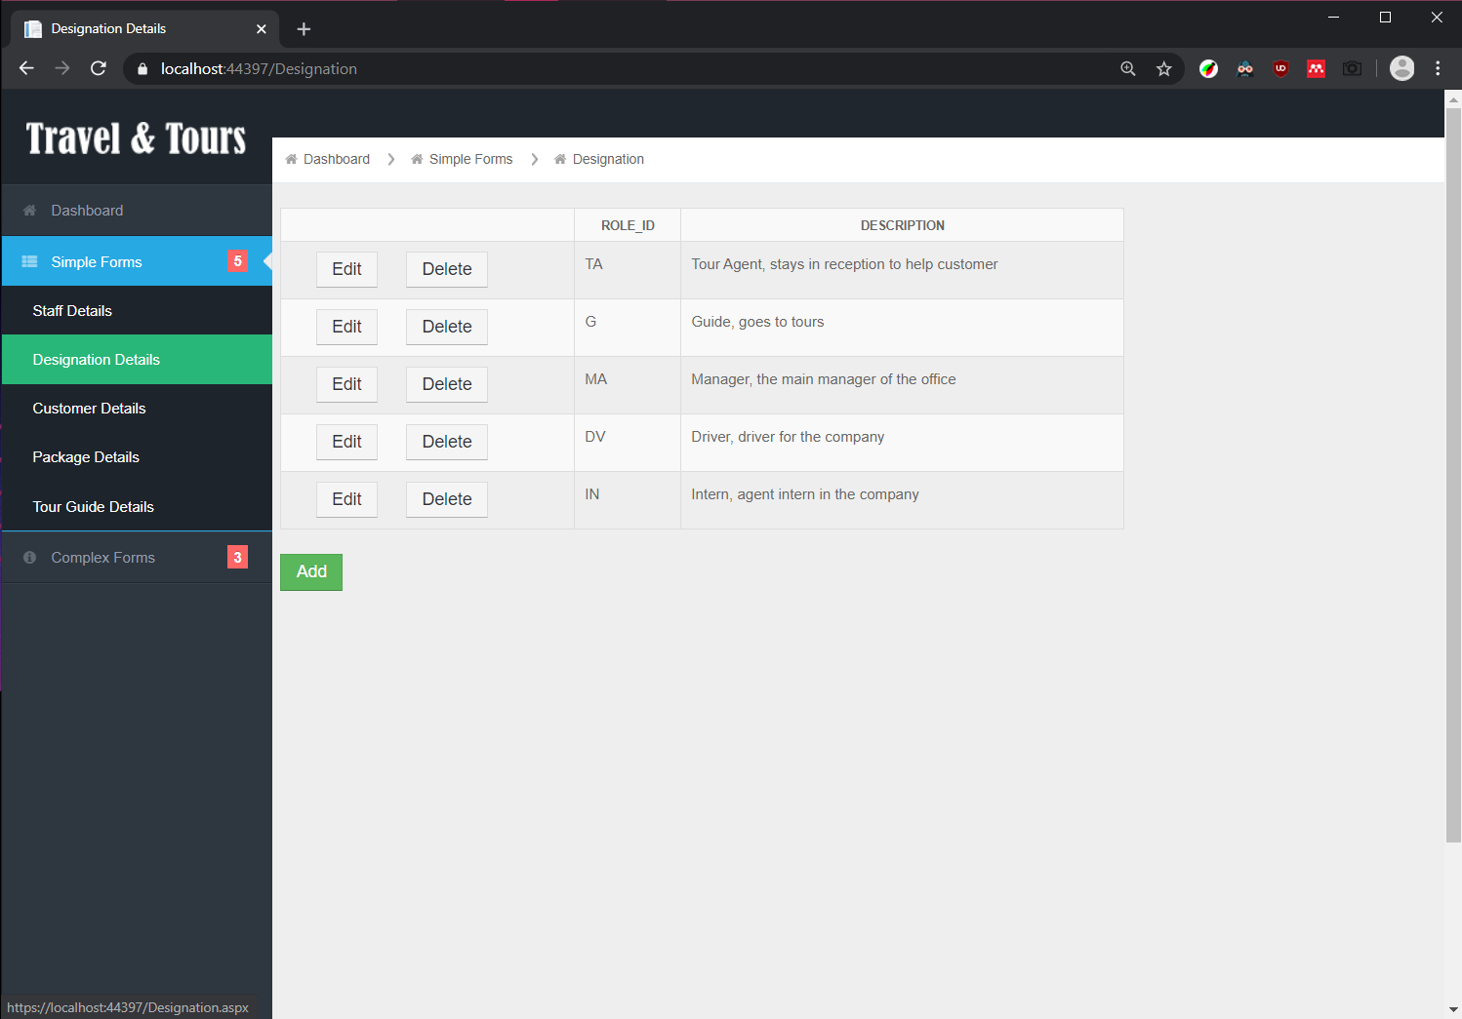

Figure : Simple Web-forms for Designation Details

### Customer Details

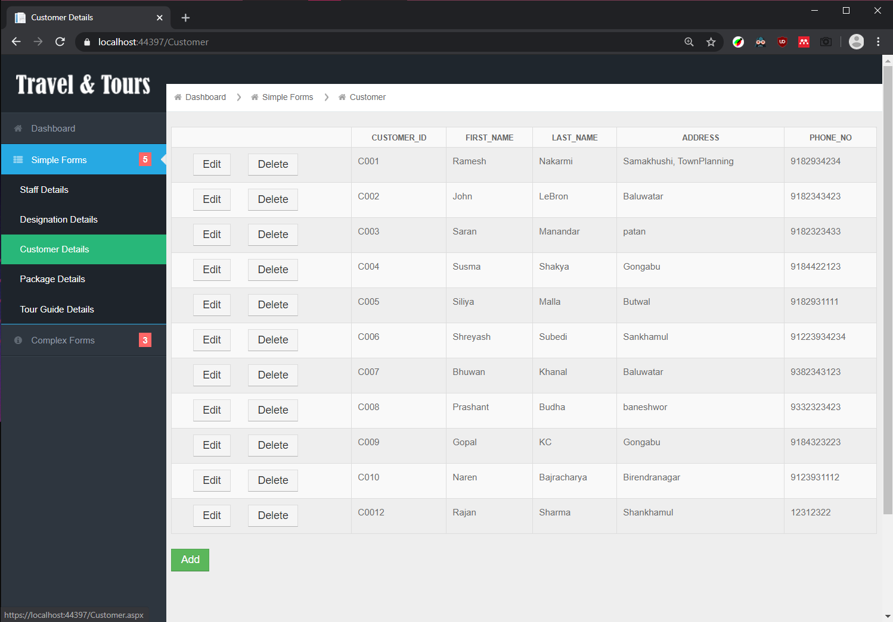

Figure : Simple Web-forms for Customer Details

### Package Details

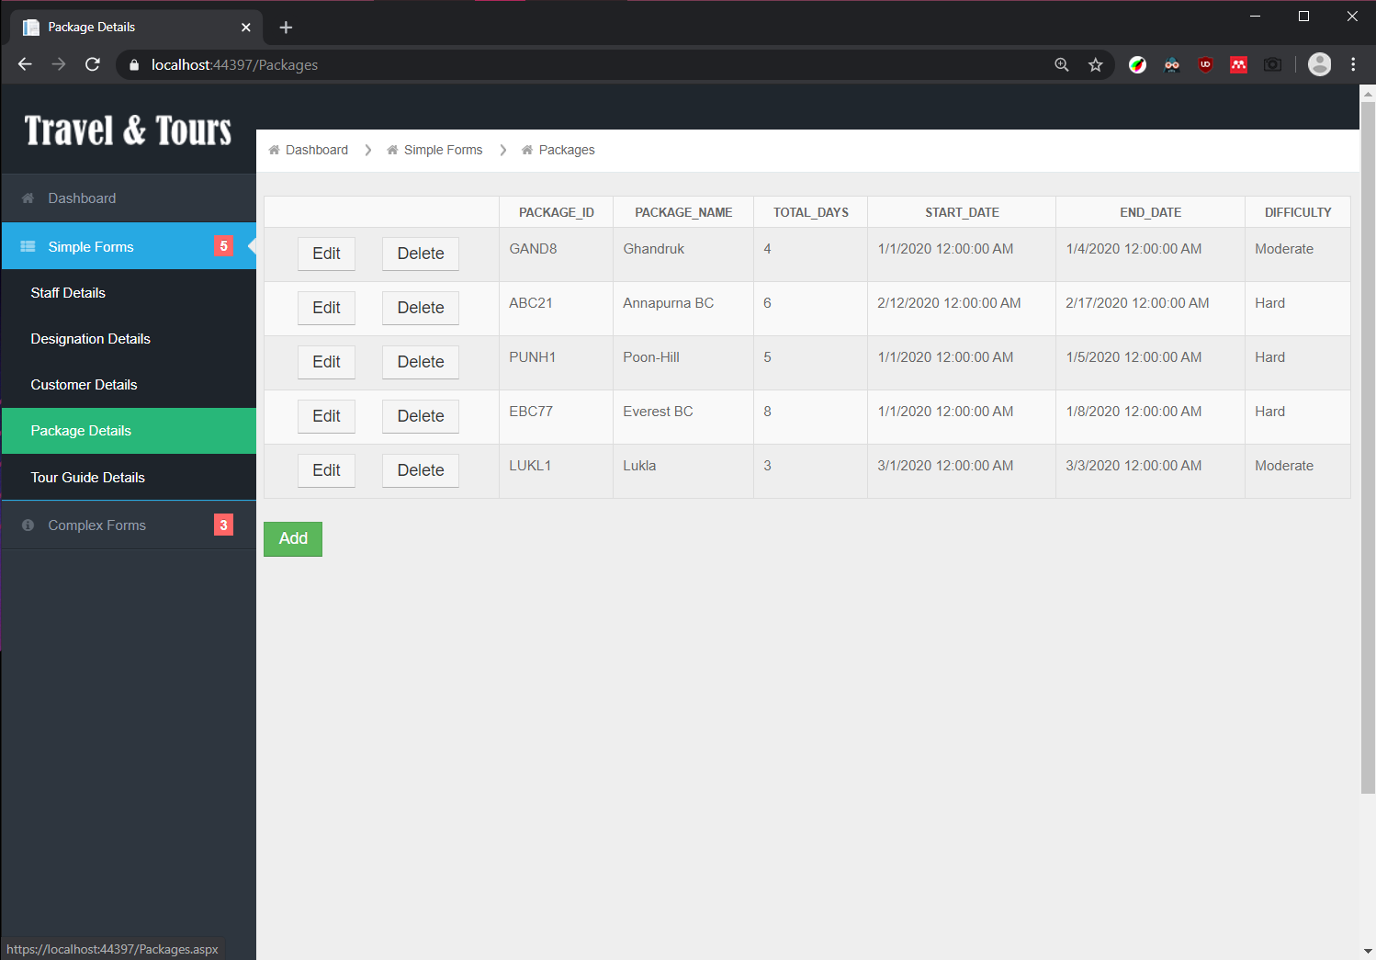

Figure : Simple Web-forms for Package Details

### Tour Guide Details

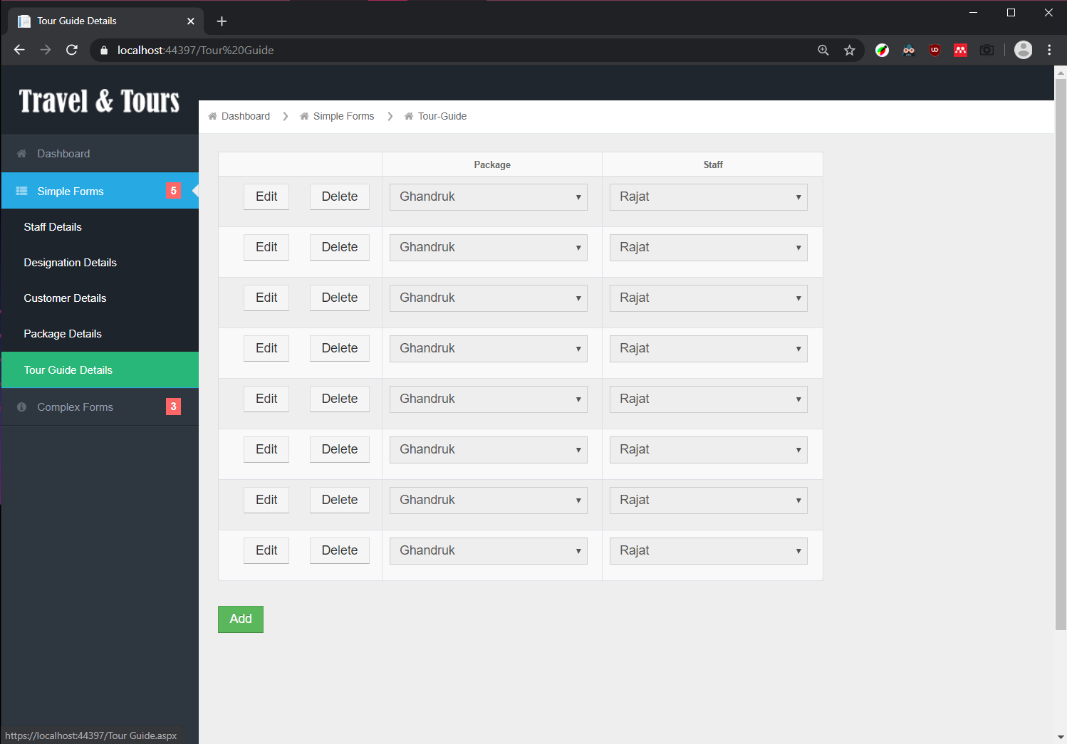

Figure : Simple Web-forms for Tour Guide Details

## 6.2. Complex Webforms

These web forms perform certain complex queries to extract information via joining various tables.

### 6.2.1. Customer-Package Schedule Form

The Customer-Package Schedule Form for any package shows the details of the package and the details of all customer who choose it.

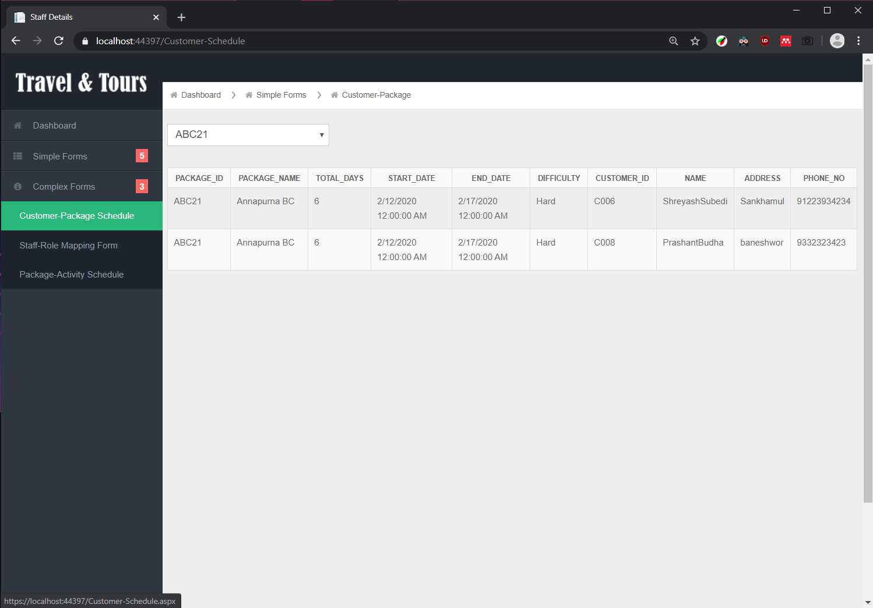

Figure : Complex Web-forms for Customer-Package Schedule Form

### 6.2.2. Staff-Role Mapping Form

Staff Role Mapping Form shows the count of staff of selected role in the company. This Form also shows additionally the details on staff members of the selected role types.

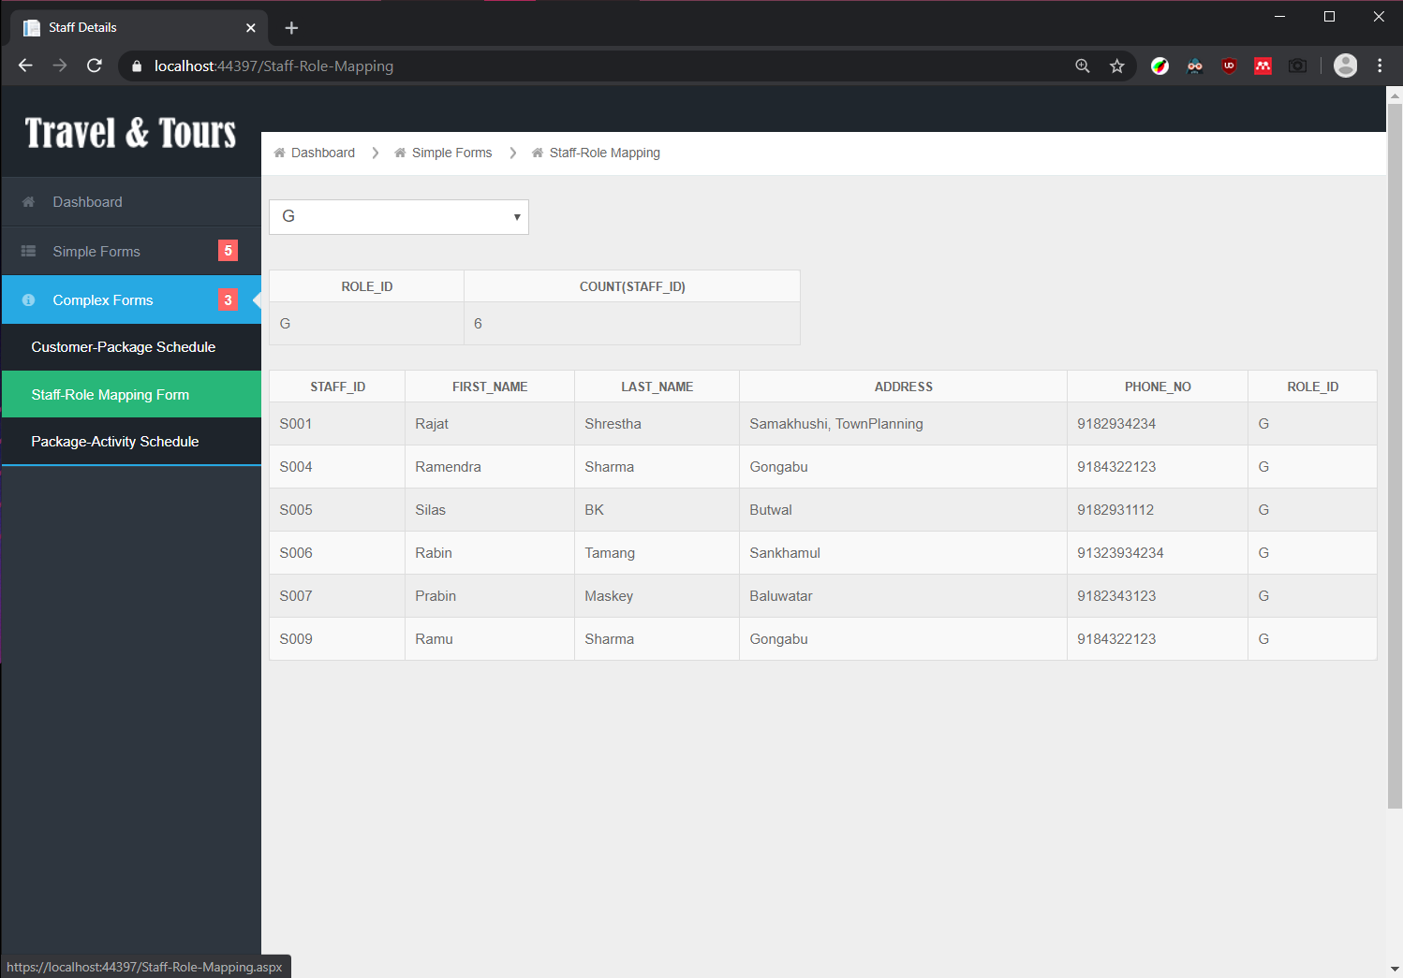

Figure : Complex Web-forms for Staff-Role Mapping Form

### 6.2.3. Package-Activity Schedule Form

Package-Activity Schedule Form shows the details of the activities, travel details, mode for any selected package

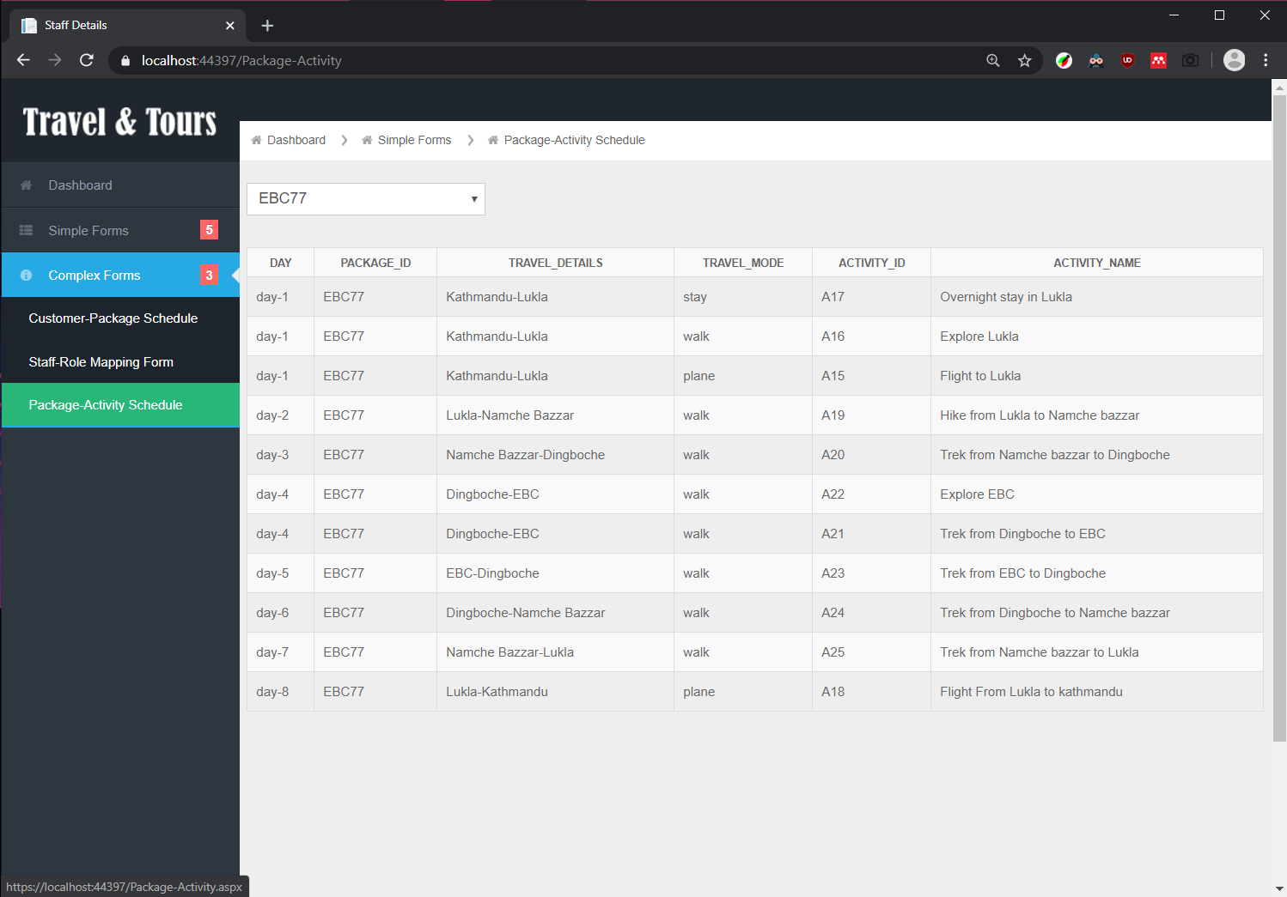

Figure : Complex Web-forms for Package Activity Schedule Form

## 6.3. Dashboard

The simple dashboard acts as the home screen of the application and shows various insights on the contents of the database. This includes links to the various simple and complex web forms. The charts show the insights on the staff count by designation and the customer count on each package. This page also contains the indicator for data inserted in each table.

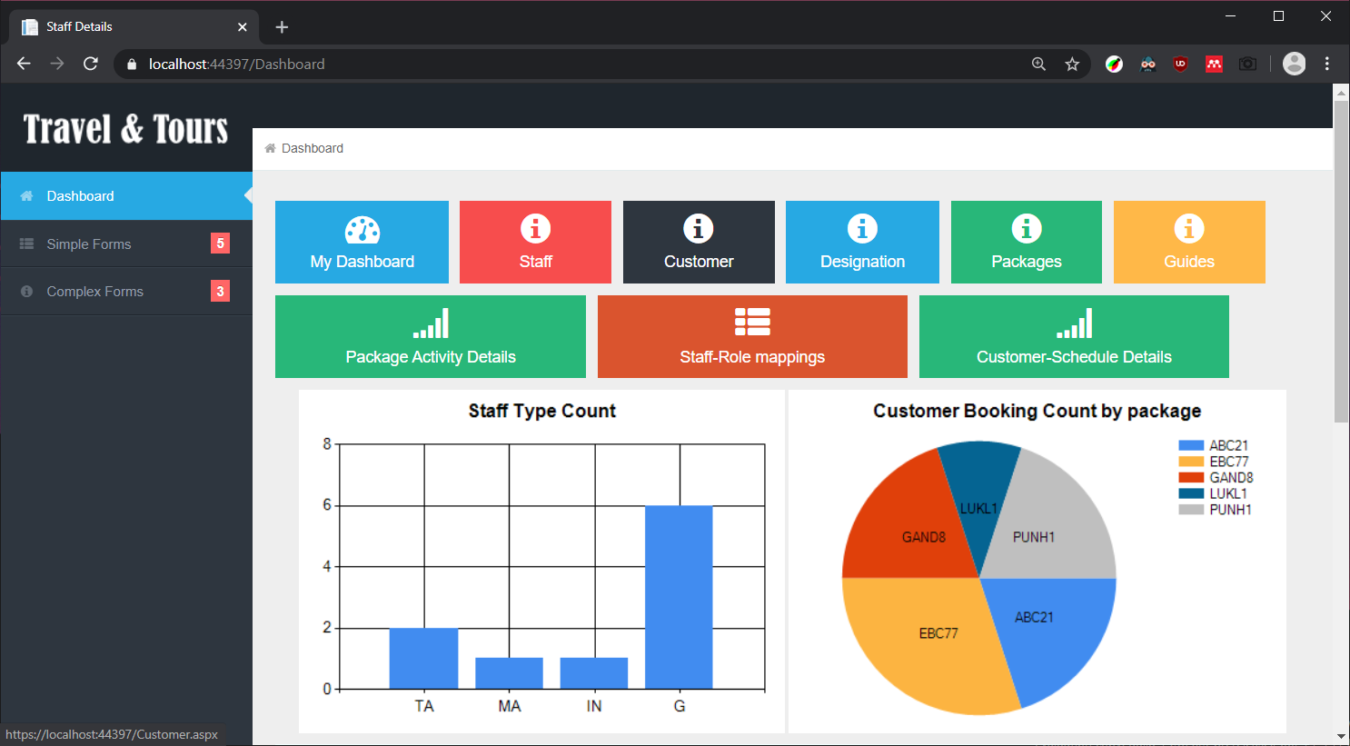

Figure : The Dashboard with Links to webforms and Charts

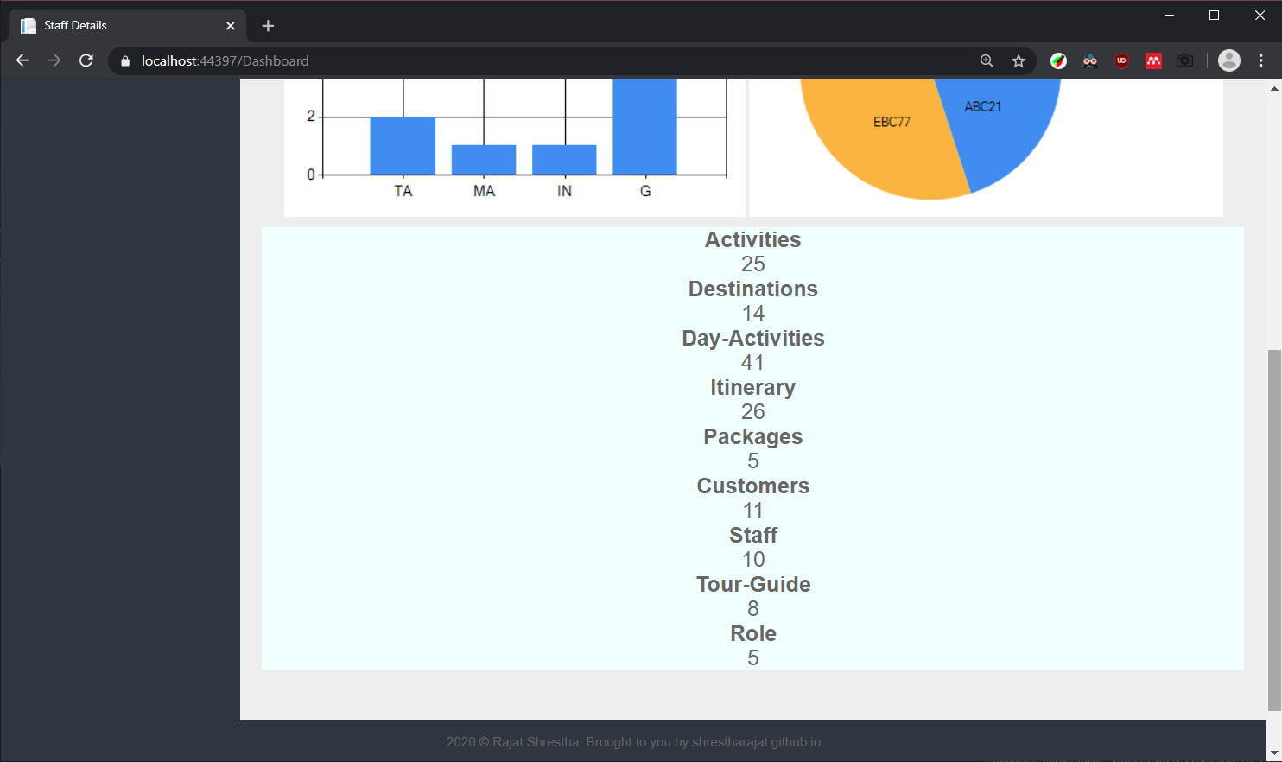

Figure : Dashboard with details on the Number of data entered in the database

# Testing:

## Simple Forms:

Since the Crud operations for the Simple forms are the same each form is selected to carry out unique tasks in the tests.

### Adding Data

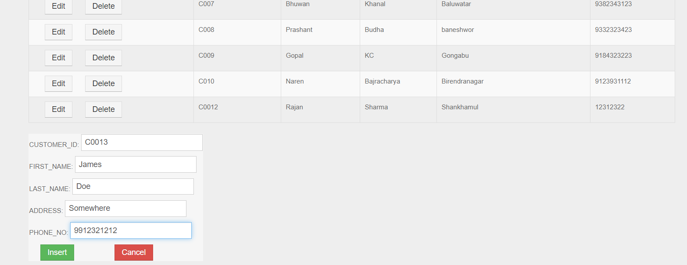

Figure : Entering Data in the Customer Form

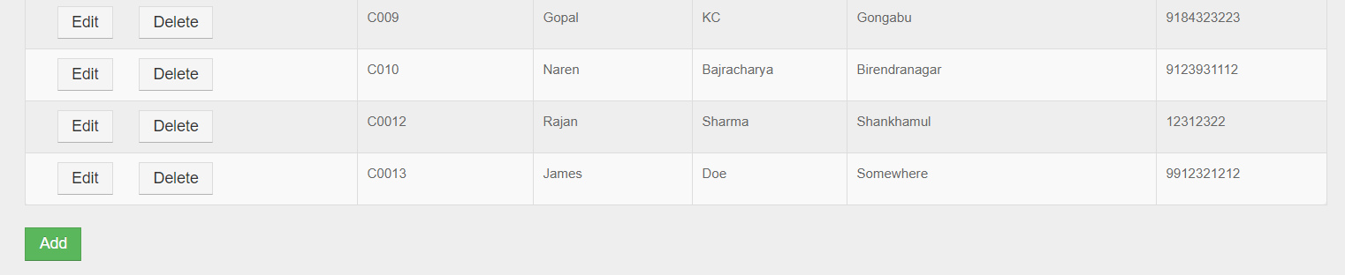

Figure : New Customer inserted in the customer table

|  |  |
| --- | --- |
| Test Summary | Adding data in Customer form |
| Action | Adding customer details |
| Expected Output | Details to be entered in table and shows up in form |
| Actual Output | Details are entered in table and are shown in the form |
| Result | Success |

Table : Test 1 Simple Form Adding Data

### Editing Data

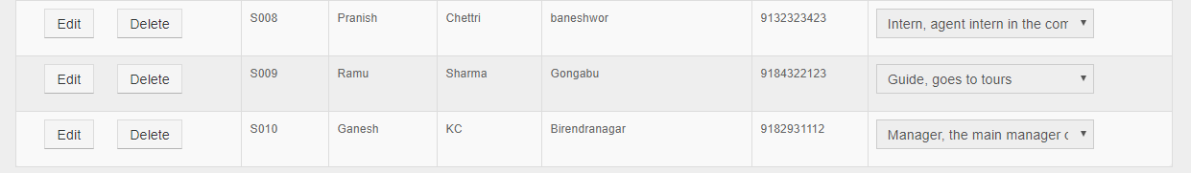

Figure : Staff data before editing

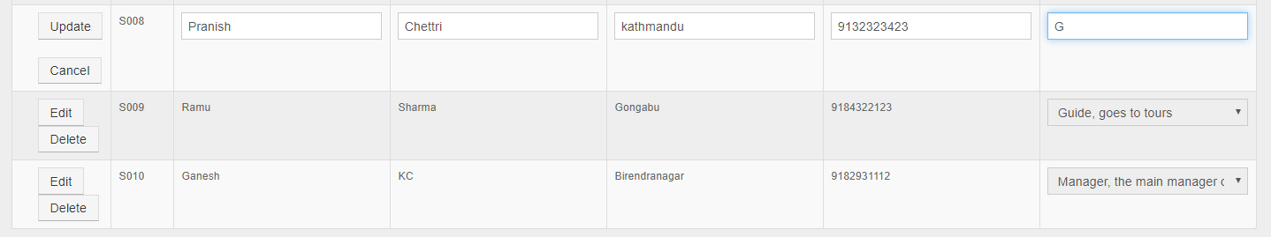

Figure : Editing Staff Data

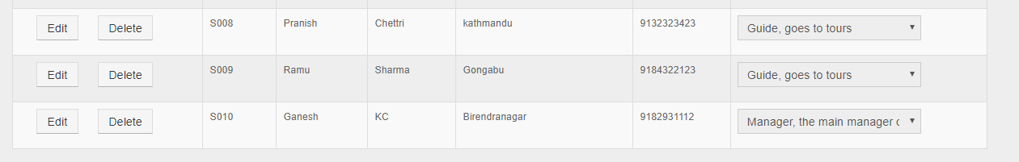

|  |  |
| --- | --- |
| Test Summary | Edit Staff Details |
| Action | Edit a staff detail in staff form |
| Expected Output | Details of a staff to be updated and Primary key should not be updated |
| Actual Output | Details of the staff is updated, and the PK was made inactive so that it could not be edited |
| Result | Success |

Figure : Staff data after editing

Table : Test 2 Simple Form Editing Data

### Deleting Data

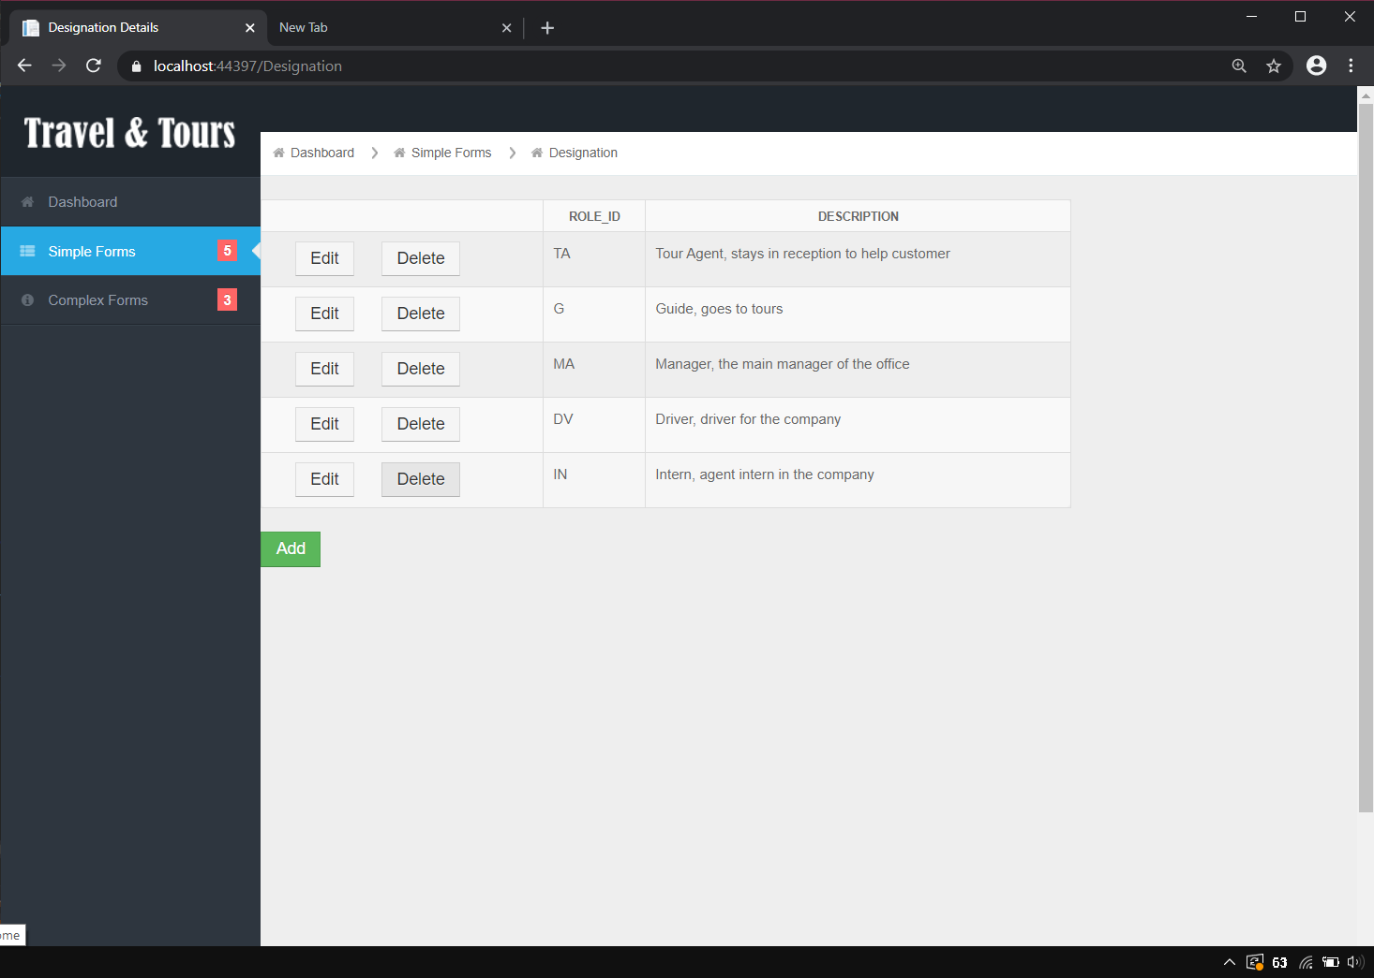

Figure : Designations before deleting

|  |  |
| --- | --- |
| Test Summary | Deleting an entry in Designation form |
| Action | Delete Intern from Designation as there are no interns |
| Expected Output | Intern to be removed |
| Actual Output | The Intern Entry was removed |
| Result | Success |

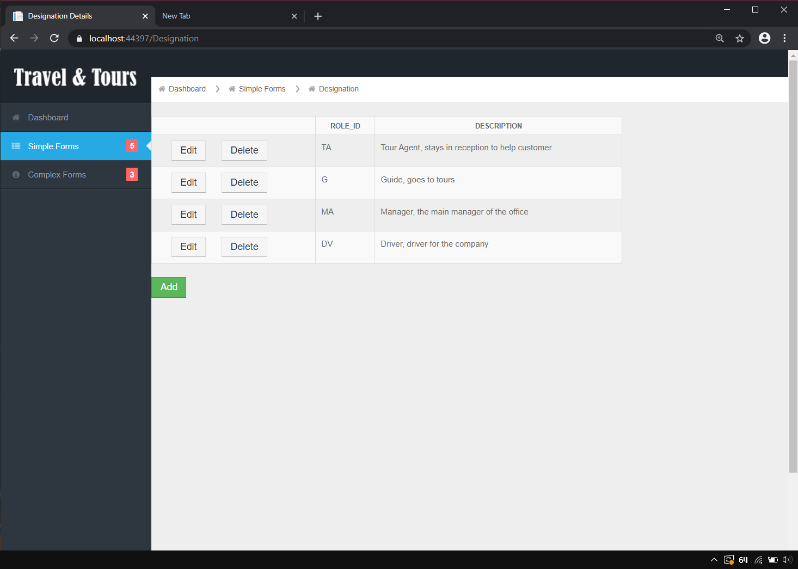

Figure : Intern designation removed after Deleting

Table : Test 3 Simple Form Removing data

### Adding Duplicate Data



Figure : Editing the Tour-guide to be duplicate

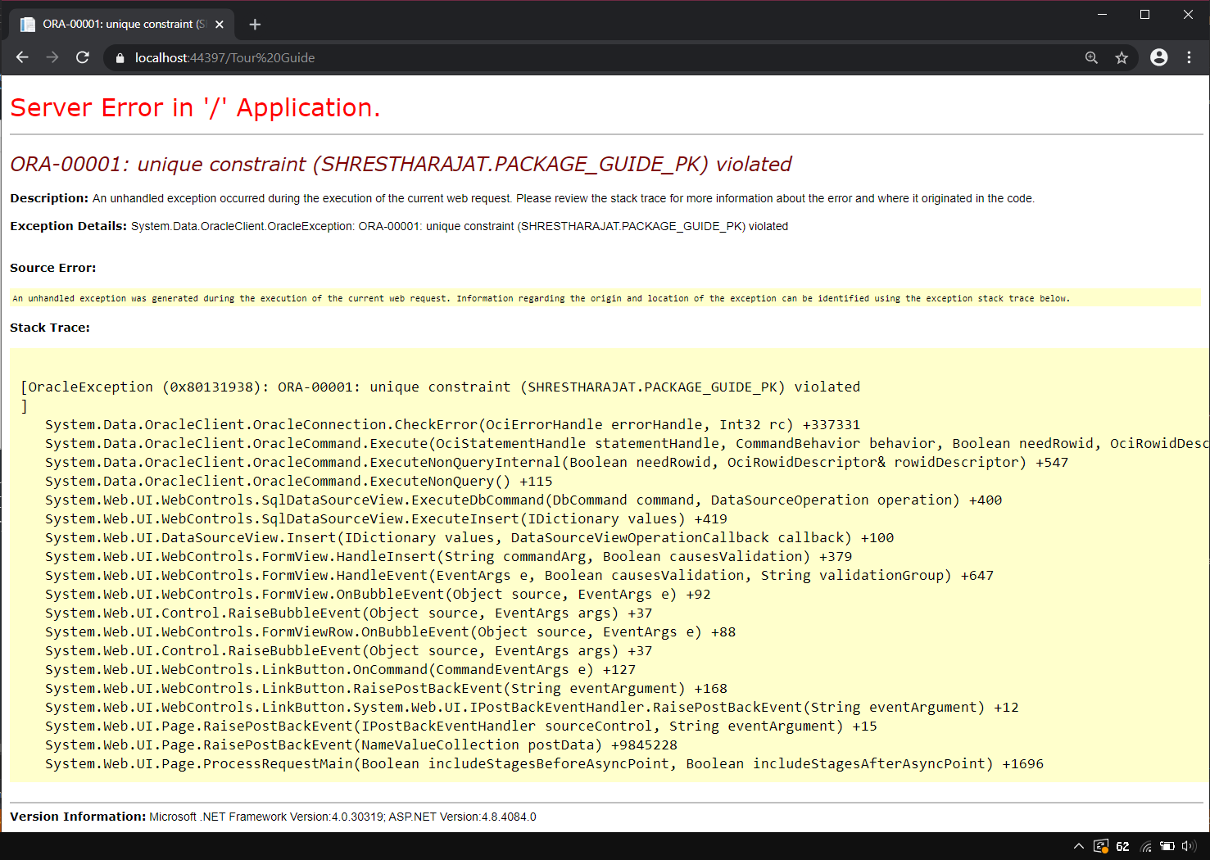

Figure : Exception occurred due to duplicate data

Table : Test 4 Simple Form Adding duplicate data

|  |  |
| --- | --- |
| Test Summary | Try to add Duplicate data in Simple Form |
| Action | Add duplicate data in tour guide form |
| Expected Output | Error occurs and halts the operation |
| Actual Output | An Exception occurred not allowing data to be entered |
| Result | Success |

### Deleting referenced entry

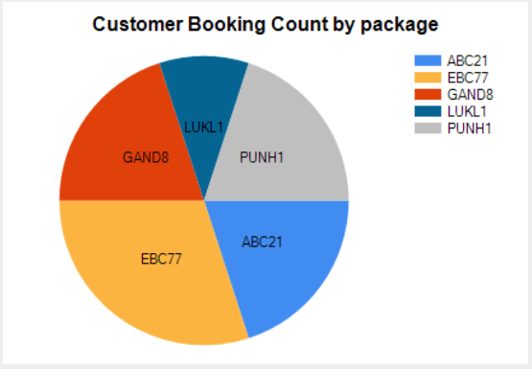

Figure : All the Packages are currently referenced

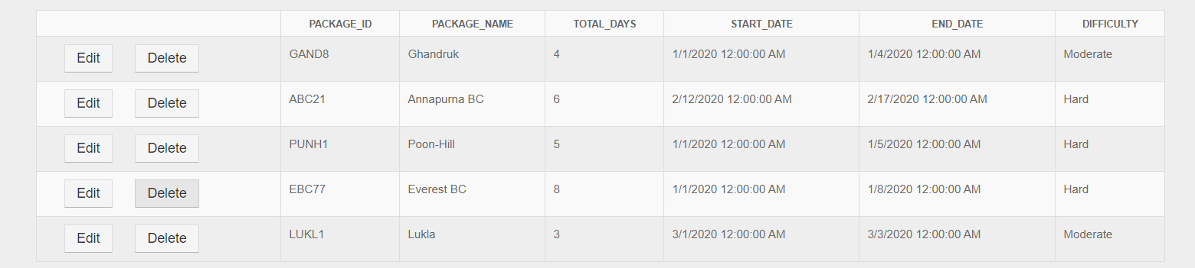

Figure : Deleting one referenced data (package)

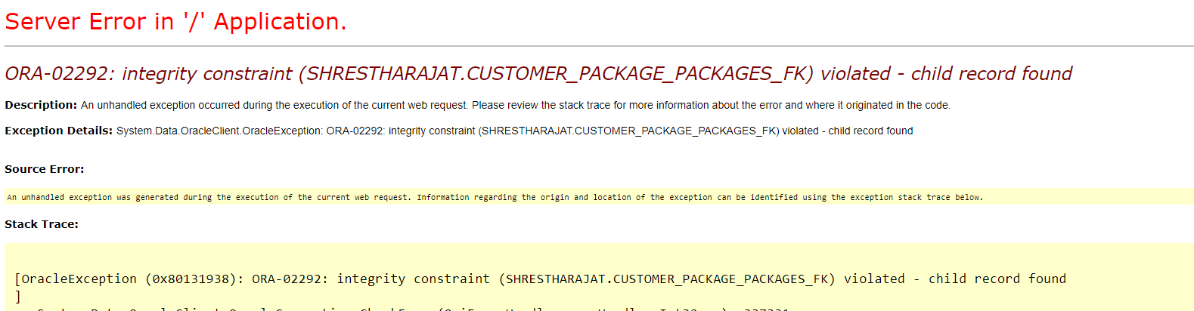

Figure : Exception occurred while deleting referenced item

|  |  |
| --- | --- |
| Test Summary | Try to delete referenced data in Simple Form |
| Action | Delete any package from package form |
| Expected Output | Error occurs and halts the operation |
| Actual Output | An Exception occurred not allowing data to be deleted |
| Result | Success |

Table : Test 5 Simple Form deleting referenced data

## Complex Forms:

### Filtering the Package-Customer Form

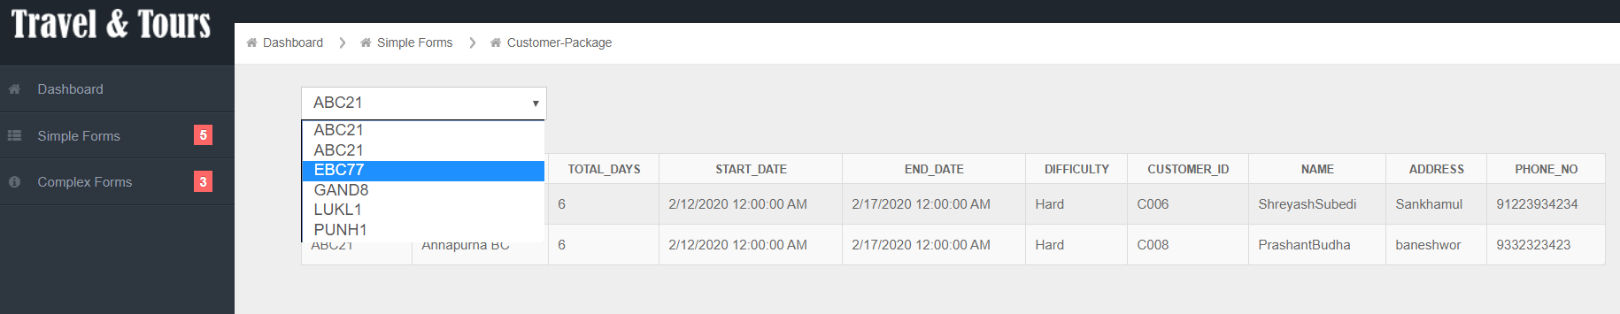

Figure : Selecting Package Id to show customer booking the selected package

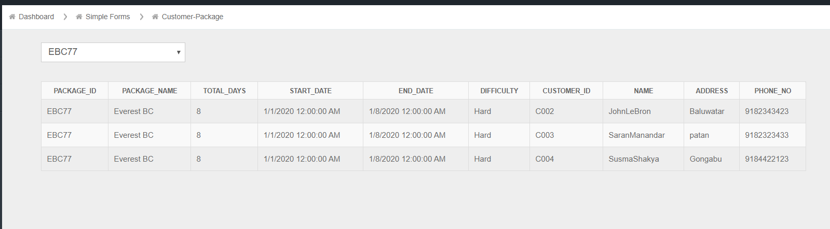

Figure : Table showing customers who is booking the selected Package

Table : Test 6 Complex Form Customer-Package Filtering

|  |  |
| --- | --- |
| Test Summary | Check the Package-Customer Filtering |
| Action | Select any Package |
| Expected Output | The table will show customer data for selected package |
| Actual Output | The table showed customer data for selected package |
| Result | Success |

### Filtering Staff-Role mapping Form

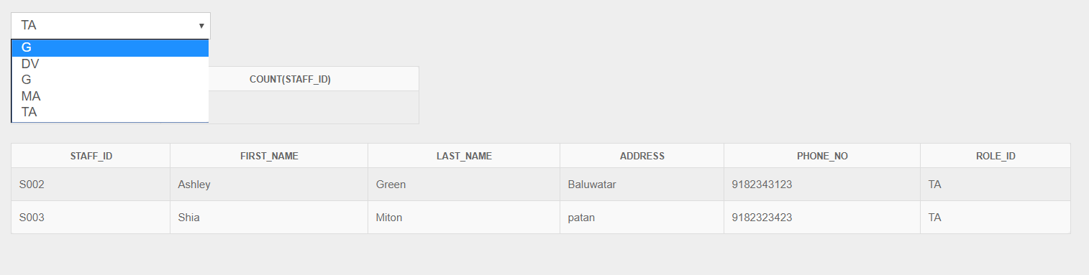

Figure : Selecting the Designation to count the no of staffs in it and staff details

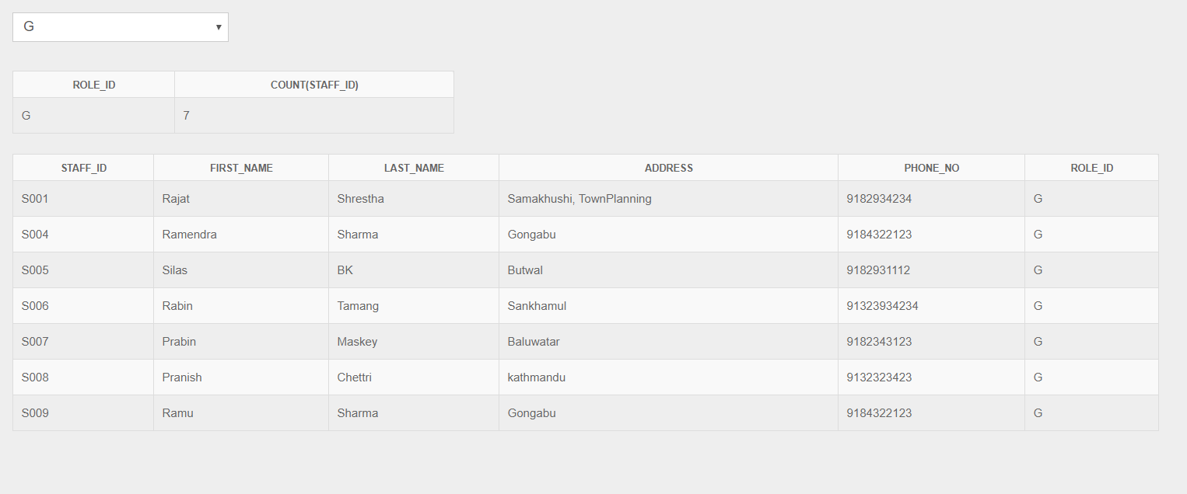

Figure : Staff details and count of the selected designation

Table : Test 7 Complex Form Staff role mapping

|  |  |
| --- | --- |
| Test Summary | Check the Staff Role mapping Filtering |
| Action | Select any Role to Filter |
| Expected Output | The table will show staff data for selected role |
| Actual Output | The table showed staff data for selected role |
| Result | Success |

### Filtering Package-Activity Schedule Form

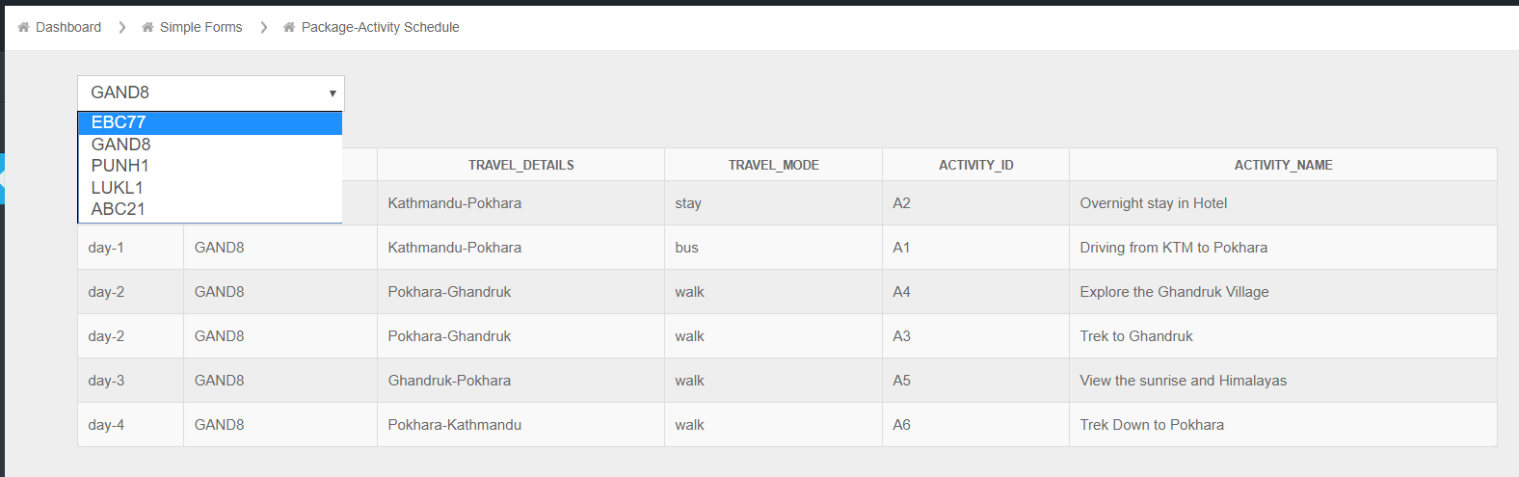

Figure : Selecting Package Id to view the enlisted activities

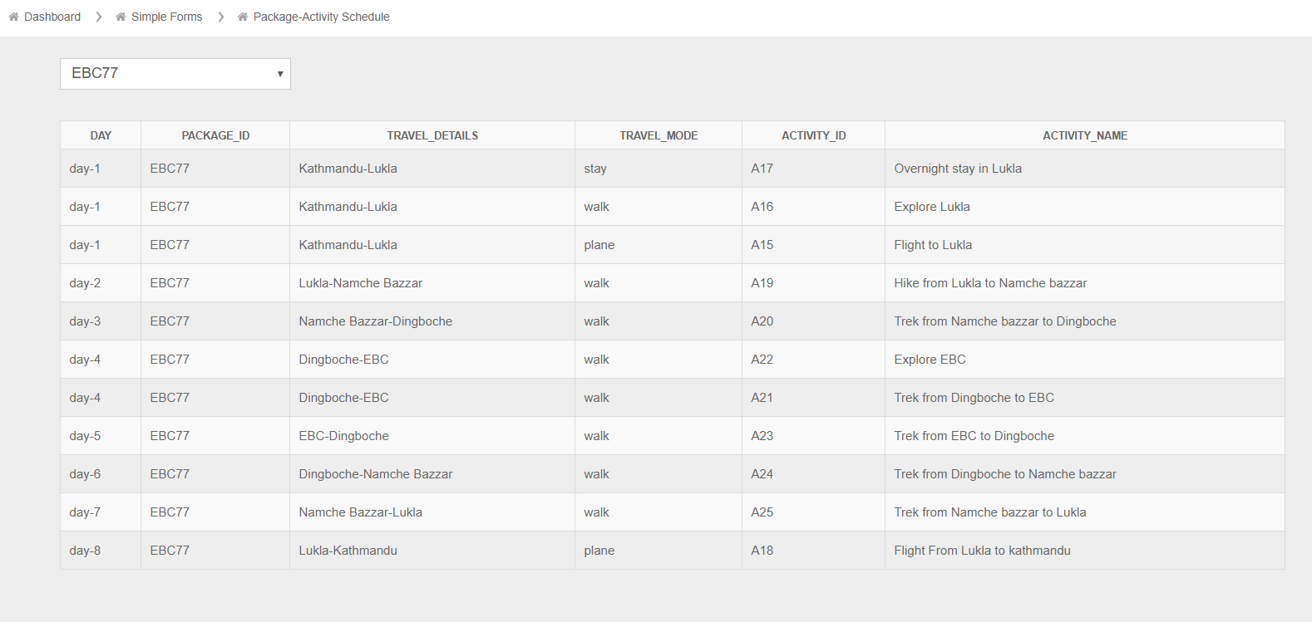

Figure : Enlisted Activities of the selected package

Table : Test 8 Complex Form Package activities

|  |  |
| --- | --- |
| Test Summary | Check the package Activity filtering |
| Action | Select any Package to view Activities |
| Expected Output | The table will Activities of the selected package |
| Actual Output | The table showed Activities of the selected package |
| Result | Success |

## Dashboard

### Testing All of the Links

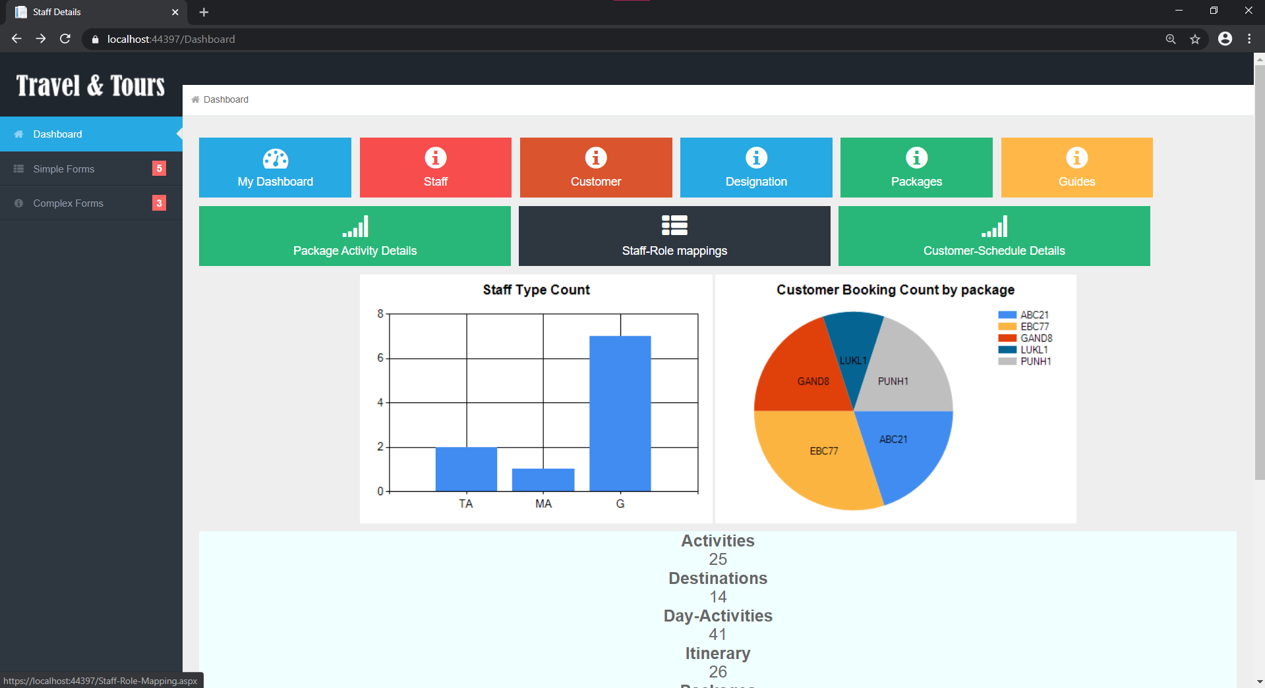

Figure : Clicking the staff role link

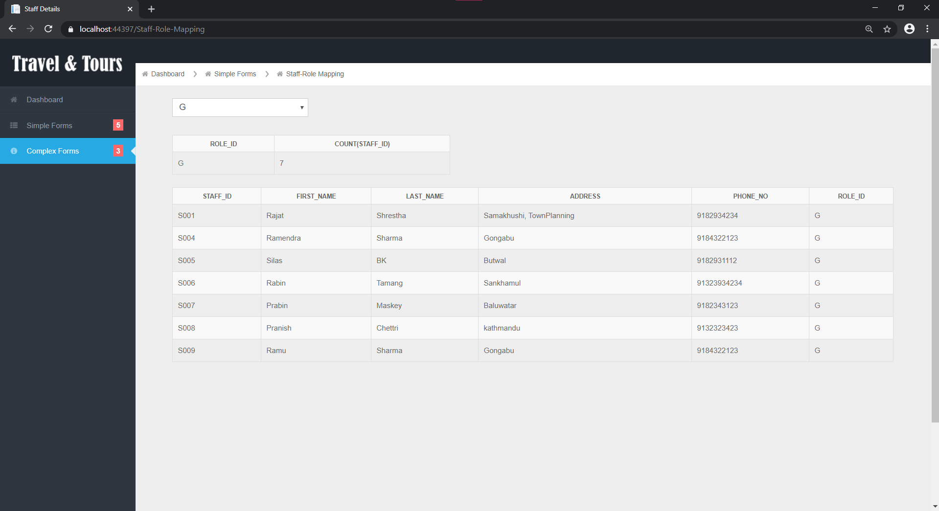

Figure : Getting redirected to the staff-role page

Table : test 9 Checking Links in dashboard

|  |  |
| --- | --- |
| Test Summary | Check the Dashboard links |
| Action | Select Staff-Role mapping link in the dashboard |
| Expected Output | The page will be redirected to the staff-role form page |
| Actual Output | The page was redirected to the staff-role form page |
| Result | Success |

### Testing the charts in the Dashboard

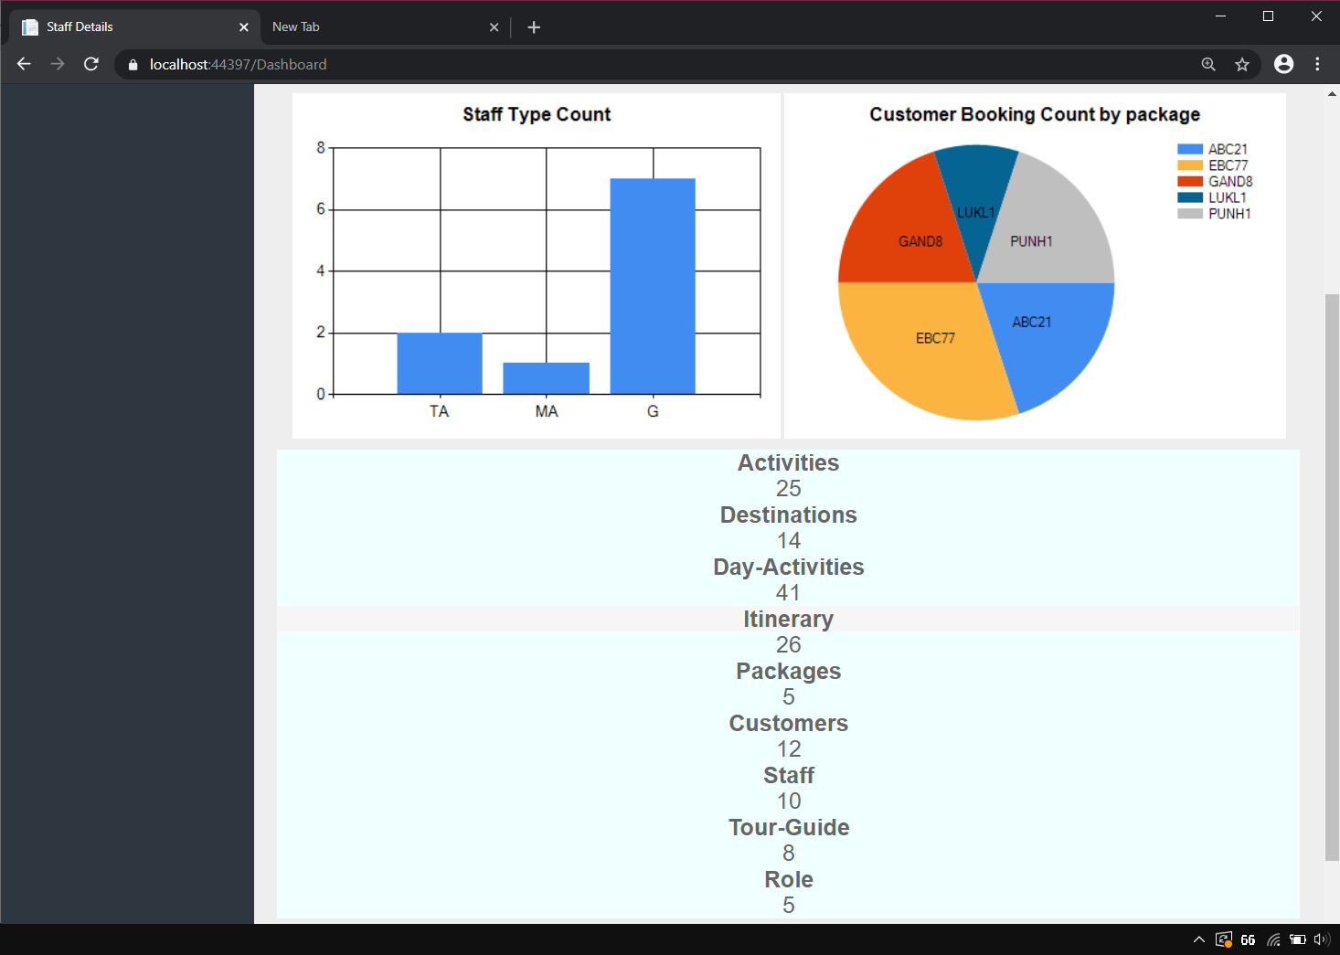

Figure : Charts and data before updating data in the database

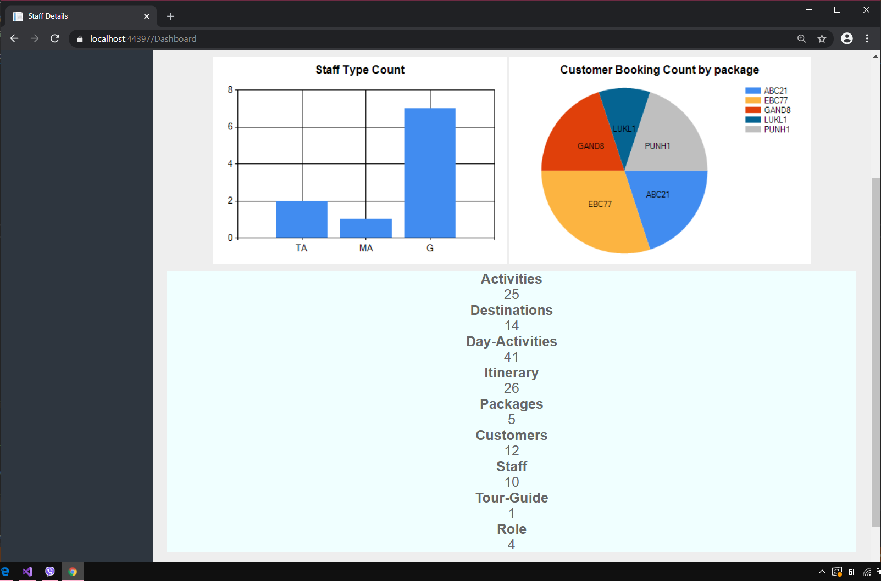

Figure : Charts and data after updating the database

|  |  |
| --- | --- |
| Test Summary | Check the Dashboard charts |
| Action | Modify Data in the Database |
| Expected Output | The Graphs will readjust according to the data in the database. |
| Actual Output | The Graphs was readjusted according to the data in the database. |
| Result | Success |

Table : Test 10: Checking Graphs in Dashboard

# User Manual

Since the Crud operations for all the form is the same steps

## CRUD Operations

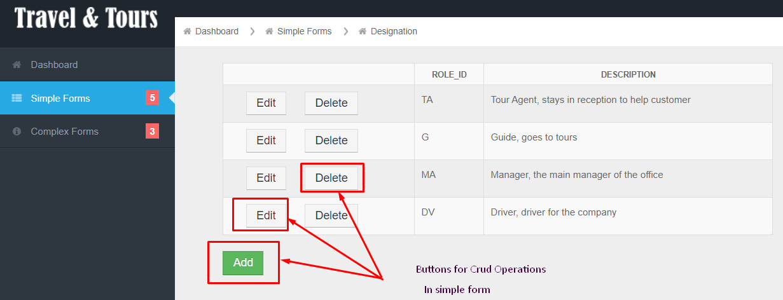

### Addition

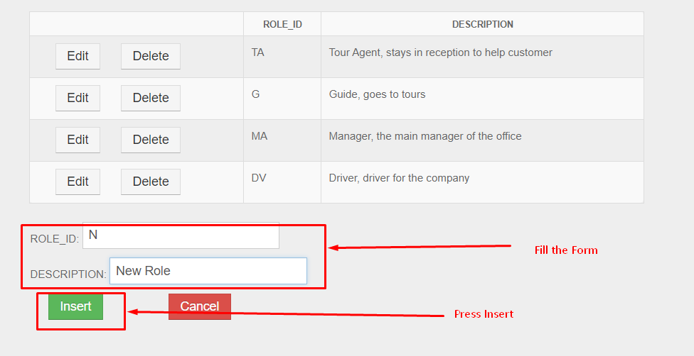

### Editing

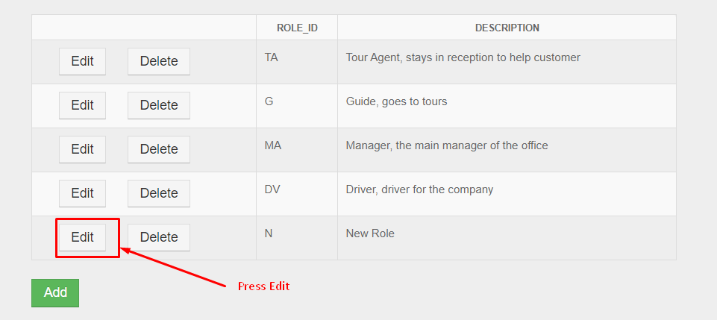

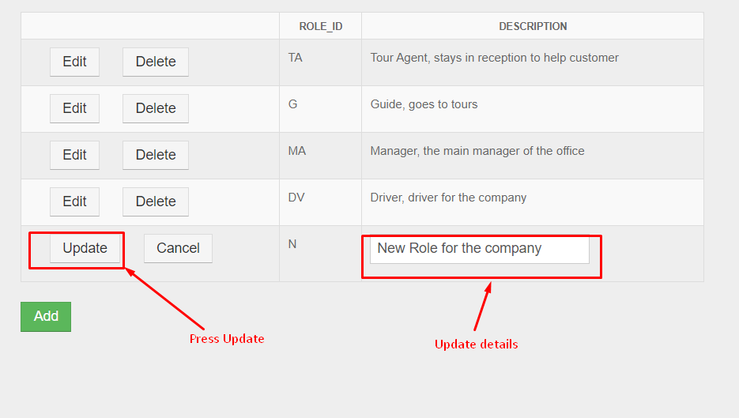

### Deleting

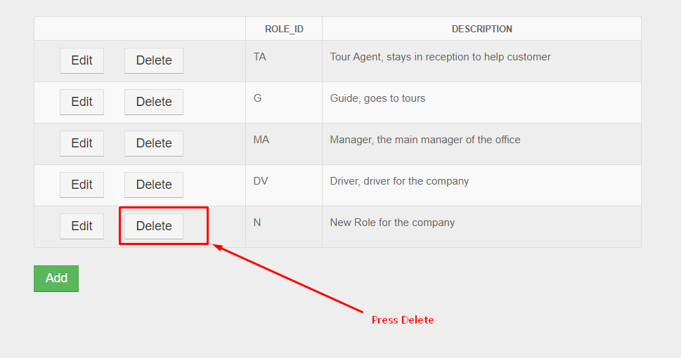

# Further Discussion

This coursework was quite fun to do and had a lot of new challenges which required various tricks and tips to continue this coursework has improved the database management and problem skills due the to the complex scenarios involving various entities and relations. Mainly this coursework focuses on using the Given tools for solving the problem:

1. Oracle database
2. Visual Studio
3. Oracle SQL Developer
4. Oracle SQL Developer Datamodeler
5. Visual Studio Code

The Following tools were essential in their own way for hosting a local database server, an Integrated Development Environment to work with ASP .NET framework, an SQL Query Developing platform, ER- Model generator and a simple text editor. After doing the required tasks using core technologies the project was further enhanced by various other technologies which improves various performance and development of the application such. The core and optional technologies used are:

1. HTML
2. CSS
3. Java Script
4. C#
5. Bootstrap
6. jQuery
7. ASP .NET
8. SQL
9. PL/SQL

tools and technologies required for the development of the given project greatly helped on understanding how different technologies work together to create a functional project and exposed various new tricks on how a developer can save time by using such technologies. This project also strongly demonstrated how coding has become easier due to various proprietary software designed to automate and make complex problems simple in the modern day.

# References

Coronel, C. & Morris, S., 2018. *Database Systems: Design, Implementation, & Management.* s.l.:Cengage Learning.

Kreines, D., 2009. *Oracle Data Dictionary Pocket Reference.* 1st ed. Chicago: O'Reilly Media.

Nishadha, 2017. *Ultimate Guide to ER Diagrams ( Entity Relationship Diagrams ).* [Online]   
Available at: https://creately.com/blog/diagrams/er-diagrams-tutorial/  
[Accessed 28 January 2020].

Oracle, 2020. *Data Modeling with Oracle SQL Developer.* [Online]   
Available at: https://www.oracle.com/in/database/technologies/appdev/datamodeler.html  
[Accessed 28 January 2020].

Scottish Qualifications Authority, 2010. *Outcome 1:Fundamentals of Database Design.* [Online]   
Available at: https://www.sqa.org.uk/e-learning/MDBS01CD/page_06.htm  
[Accessed 12 1 2019].

Watt, A., 2012. *Database Design.* 2nd ed. Vancouver: BCcampus Open Textbook.

### 

# Appendix